

**AI and Labour Markets**

**ARTIFICIAL INTELLIGENCE - ITS POTENTIAL IMPACT ON THE LABOUR MARKET AND THE ECONOMY.**

**Robert Nutter.**

Much has been written in recent years as to how automation – increasingly seen via the use of robots and artificial intelligence (AI) - will affect employment, productivity and economic growth. Automation is basically an overarching term which involves making hardware or software that is capable of doing things automatically. Fire alarm systems which are used in buildings are an example of automation. As soon as smoke activates the sensors water automatically starts pouring through the sprinklers. Automation has been part of our lives for decades going back to the Industrial Revolution of the nineteenth century kinked to the application of division of labour in manufacturing industry. Throughout history jobs have been destroyed because of new innovations. For example, a ‘knocker-up’ used to be a profession in the UK – their job was to wake up workers. But this became extinct after the wind-up alarm clock was invented. In textile weaving the automatic Northrop loom which appeared in the 1890s meant that a loom operative could work 16 or more looms whereas previously they could only operate 8. The continued advance of automation has now been supplemented by AI which is branch of computer science which involves making ‘intelligent’ machines or software mimic human behaviour and intelligence.

AI could boost the global economy by as much as the steam engine did during the industrial revolution in the nineteenth century. AI is made effective by accomplishing repetitive tasks more efficiently than humans as a result of using large amounts of data to copy human behaviour (digitisation). The McKinsey Global Institute has estimated that AI will contribute $13 trillion to global GDP by 2030 and they add that AI will have been adopted in some form by 70% of companies boosting GDP growth by 1.2% per year. According to international research by Deloitte 38% of firms expect certain jobs to be eliminated by some form of automation within the next three years (Figure 1).

People with repetitive, time consuming or manual jobs such as those working in factories, distribution or transport are particularly vulnerable to AI. Indeed because of the simple nature of some of the tasks in these sectors, AI wouldn’t need to be particularly sophisticated to replace them completely. Amazon’s warehouses show the potential for AI in distribution using robots to pick goods for customers’ orders as shown in this clip <https://www.youtube.com/watch?v=Ox05Bks2Q3s>. A good example of the use of robots in manufacturing is seen in the BMW factory at Cowley in Oxford as seen in this BBC clip <https://www.bbc.com/teach/class-clips-video/business-ks4-gcse-steph-mcgovern/zd84xyc>. Up to 20% of shop assistants and cashiers could find their jobs eliminated by automation. The British Safety Council predicts that jobs in accommodation, food services, agriculture and retailing are at high risk of automation. Up to a fifth of shop assistants and cashiers could find their jobs eliminated. Many jobs in the North of England are vulnerable to AI while the South may find that AI brings rising real wages and increased employment, because it brings about increased productivity, and allows highly skilled individuals to dispense with the more mundane aspects of their jobs.

According to work carried by Centre for Cities more than 1 in 4 jobs in Mansfield, Stoke, Doncaster and Blackburn are at risk from robots over the next decade while just 13% of jobs in Oxford and Cambridge are under threat. Clearly some jobs are more vulnerable to AI than others. In developed economies general skills such as emotional intelligence and communication which AI technologies find difficult to reproduce are likely to enjoy increasing demand with this pool of workers enjoying significant wage growth. Other workers vulnerable to job loss as a result of AI are likely to need new skills as repetitive relatively low skill manual jobs are carried out by robots.

**Figure 1.**

|  |  |  |
| --- | --- | --- |
| **Industry** | **Employment (000s)** | **Percentage of jobs with the potential for automation.** |
| Accommodation and food services | 1784 | 65 |
| Agriculture, forestry and fishing | 351 | 61 |
| Construction | 2367 | 45 |
| Education | 3266 | 27 |
| Health and social work | 4177 | 35 |
| Information and communication | 1278 | 23 |
| Manufacturing | 2943 | 49 |
| Professional, scientific and  technical activities | 2340 | 32 |
| Transport and storage | 1602 | 58 |
| Wholesale, retail and repair of motor vehicles | 4195 | 64 |

Source: IPPR report, Managing Automation, 2017, and ONS, UK labour market 2017.

See the links below from the Bank of England and the BBC.

<https://www.bankofengland.co.uk/knowledgebank/will-a-robot-takeover-my-job>

<https://www.bbc.co.uk/news/technology-34066941>

In banking automation, as seen with ATMs, has for many years freed up many banking employees to provide their personal expertise to help clients with decisions on investments and lending. However, bank branches have continued to close as more people no longer regularly need a bank branch using their debit cards and phones to buy goods and services and the internet to monitor their bank accounts. Indeed the number of ATMs has been in decline in recent years as society becomes increasingly cashless.

Nat West bank have now used AI to develop a digital human which speaks to customers with queries leaving only the more complex financial issues to be dealt with by bank employees. AI can also be used to automatically switch households to the lowest energy tariffs. Liverpool Victoria are using a computer to view images of damage to vehicles following a car crash to assess whether the car should be written off. In California an algorithm is being used to clear a backlog of marijuana convictions for recreational use enabling many people to gain employment. IBM-Watson have developed AI to enable robots to diagnose cancer. During a colon ostomy AI can be used to spot small polyps of abnormal tissue – very often 1 in 5 pre-cancerous polyps are missed by medics using the naked eye.

One of the most pressing problems facing governments in developed economies in the years ahead is an ageing population. In the UK the cost of social care will require an extra £6.1bn by 2030. AI may provide a partial solution given that social care provision is a low pay labour intensive sector. Since 2000 productivity in the social care sector has fallen by 10% which means that it is half the UK average. According to the Office of National Statistics 54% of care jobs are threatened by robots. Indeed robots can also be used to feed people with disabilities using an assistive dexterous arm. Application of AI has the potential to increase the quality of care significantly by allowing staff to focus on higher value added tasks such as conversations with patients etc.

According to a 2011 report by McKinsey’s Global Institute Report the UK was then only operating at 17% of its digitisation potential. There is thus enormous potential to increase the UK’s poor productivity performance via AI and robotics on the coming years.

How could the impact of these new technologies impact on the labour market from a theoretical point of view? Automation etc will in certain jobs reduce the demand for labour as capital becomes more efficient at performing certain tasks thus shifting the demand curve for labour (the marginal revenue product curve) to the left as firms substitute capital in place of labour (Figure 2). Also as capital via AI can easily replace labour in jobs which involve manual repetitive low skill work a rise in wages will also lead to a significant fall in the quantity of labour demanded making the demand curve for labour in some jobs more elastic. In Figure 3 the demand curve for labour will become more like labour demand curve 2. In the above circumstances automation will do significant damage to real wages and employment. Workers presently working in jobs vulnerable to AI face the need to retrain or being the victim of structural unemployment.

**Figure 2.**

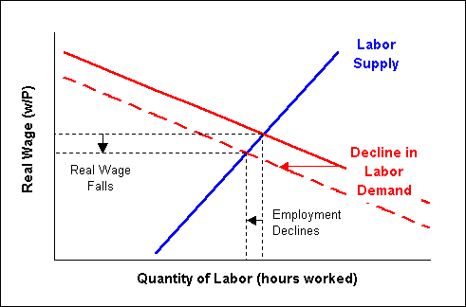

**Figure 3.**

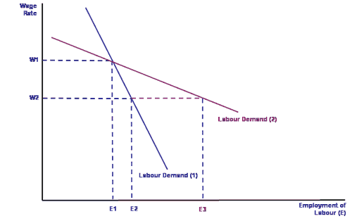

However, AI will bring higher employment and increased real wages for employees in for instance software engineering and robot maintenance. For many workers AI could enhance their job eg in medicine, banking and education thus increasing their productivity. AI will increase productivity throughout the economy, improving the UK’s competitiveness and trend growth rate leading to an increase in living standards. AI will over time shift the long run aggregate supply curve to the right. Increased prosperity will quite possibly create new jobs that may not have existed before. For example dog walkers, personal trainers and Pilates teachers have emerged from nowhere in recent years.

James Bessen argues that automation can lead to employment growth in some industries while leading to job losses at other times and in other industries. Despite widespread concerns that AI will displace huge numbers of workers he argues that it is how the new technology affects quantity demanded of the product or service that is the key to its effect on employment. New technology such as AI will supposedly reduce costs of production and the supply curve for the product affected will shift to the right reducing the price of the product (Figure 4). A straight line demand curve is elastic in the upper section and increasingly inelastic below the mid-point. When demand is price elastic changes in price resulting from the fall in costs of production will lead to a rise in revenue for a firm. If the demand for the product grows fast enough, then the demand for labour (a derived demand) will increase despite automation reducing the labour required per unit of output. This can offset the labour-saving effects of automation always assuming that there is a lot of latent consumer demand that will emerge as the price falls. It is worth pointing out that along a straight line demand curve any given fall in price leads to the same absolute rise in quantity demanded– thus revenue will either rise or fall only slowly as price falls.

**Figure 4.**

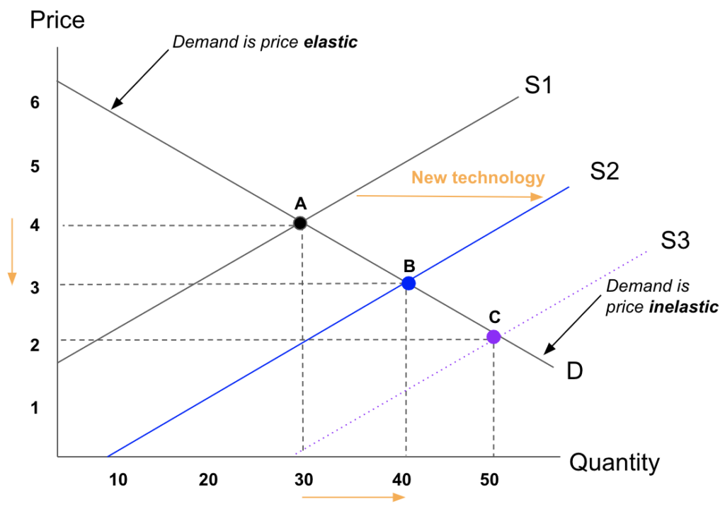

When productivity-enhancing technologies continue to lower the costs per unit, and thus lowering the prices, consumer demand will become more fully satisfied. This means that at S3 in Figure 4 demand becomes price inelastic nearer the bottom of a demand curve. This means that lower prices resulting from automation will only bring about relatively small changes in the quantity demanded and a fall in revenue. Thus the fall in price resulting from automation is insufficient to raise net employment.

James Bessen’s argument is that technological change alone is not sufficient in determining the impacts of technologies on employment. It is important to know the nature of demand for products and services affected by technological change in order to determine whether major new technologies such as AI will increase or decrease employment. If demand for a particular product or service is highly elastic and AI does not completely automate the production of that product or service, then technological change would createjobs rather destroy them. In this scenario, faster rates of productivity-enhancing change by AI would create employment to meet consumer demand. However markets can reach a saturation point – for example a few years ago the demand for Kindle devices was very buoyant as more and more people were attracted to the benefits of holding many hard copy books on an electronic device. It could now be argued that everyone who wants a Kindle has one or uses tablets such as an iPad or their Smartphone to download eBooks instead.

Without doubt AI is here to stay and will have significant effects on how we work replacing or supporting human decision making with automated algorithms which involve using sophisticated software to handle huge amounts of data. According to Oliver Pickup in Raconteur (12/05/19) “AI with the correct guidance can drive cars, automate systems, understand speech, diagnose life threatening conditions and predict business outcomes in ways, and at a speed, beyond the comprehension for us mere mortals”

Sources:

How automation could boost employment. The role of demand. <https://bitsandatoms.co/how-ai-automation-could-boost-employment-the-role-of-demand/>

Philip Aldrick: The Times 14/5/19.

Bessen, James. 2018. “AI and Jobs: The Role of Demand.” Working Paper Series. National Bureau of Economic Research.