AS/A LEVEL ENGLISH LANGUAGE

UNDERSTANDING...

THE NATURE OF WRITING

**Understanding the Key Features of Writing**

In your studies, you should be developing an understanding of the key features of written language, such as permanence, communication over distance, delayed feedback, role of editing, punctuation, typography, grammatical structure etc.

You should expand your studies to develop a growing awareness and understanding of textual conventions that could include (but not limited to) the following:

* language(s) of journalism (e.g. articles, reports, editorials, opinions, obituaries, reviews)
* language(s) of advertising (e.g. leaflets, pamphlets, slogans, tag lines)
* language(s) of fiction (contemporary or pre-1900 prose)
* language(s) of literary non-fiction (e.g. travel writing, essays, autobiography, biography, memoir).

**Independent activities:**

a) Select a range of different newspaper headlines and use the question framework sheet below to make notes ready to feedback to your class.

b) Try writing the same uncomfortable, awkward or unpleasant information in three different media: a text message, an email and a letter. After this, analysis each version using the questions below:

1. how the different forms of communication alter the lexical and grammatical structures employed by the senders
2. how the contexts of production and reception are subtly but importantly changed when the exchange takes place using forms of communication which delay the responses.

**The Grammar of Speech and Writing**

*“She didn’t do nothing.”*

*“We was there all night.”*

*“He done that hisself.”*

**Activity 1:**

1. What are your thoughts on the sentences above? Write up your notes to this question and the ones below to be discussed with your class.
2. If you were an English teacher and one of your students produced sentences like the ones above, what would you think? What would you say to the student?
3. Have you ever written sentences like the ones above? What comments did your teacher make?
4. Would it be more acceptable to use sentences like these in speech rather than in writing? Explain.

**Activity 2:**

a) Read the two versions of the fairy tale ‘The Three Bears’, printed below. Write a 4 or 5 sentence overview for each which demonstrate that you have engaged with the texts.

**Text 1**: An extract from ‘*The Story of the Three Bears*’, Robert Southey (1837)

This fairy story was being told orally in Britain from the 1830s, but Southey was the first to record it in his collection of prose writings, *The Doctor*.

One day, after they had made the porridge for their breakfast, and poured it into their porridge-pots, they walked out into the wood while the porridge was cooling, that they might not burn their mouths, by beginning too soon to eat it. And while they were walking, a little old Woman came to the house. She could not have been a good, honest old Woman; for first she looked in at the window, and then she peeped in at the keyhole; and seeing nobody in the house, she lifted the latch. The door was not fastened, because the Bears were good Bears, who did nobody any harm, and never suspected that any body would harm them. So the little old Woman opened the door, and went in; and well pleased she was when she saw the porridge on the table. If she had been a good little old Woman, she would have waited till the Bears came home, and then, perhaps, they would have asked her to breakfast; for they were good Bears, —a little rough or so, as the manner of Bears is, but for all that very good-natured and hospitable. But she was an impudent, bad old Woman, and set about helping herself.

So first she tasted the porridge of the Great, Huge Bear, and that was too hot for her; and she said a bad word about that. And then she tasted the porridge of the Middle Bear, and that was too cold for her; and she said a bad word about that too. And then she went to the porridge of the Little, Small, Wee Bear, and tasted that; and that was neither too hot, nor too cold, but just right; and she liked it so well, that she ate it all up: but the naughty old Woman said a bad word about the little porridge-pot, because it did not hold enough for her.

Then the little old Woman sate down in the chair of the Great, Huge Bear, and that was too hard for her. And then she sate down in the chair of the Middle Bear, and that was too soft for her. And then she sate down in the chair of the Little, Small, Wee Bear, and that was neither too hard, nor too soft, but just right. So she seated herself in it, and there she sate till the bottom of the chair came out, and down came her’s, plump upon the ground. And the naughty old Woman said a wicked word about that too.

**SUMMARY**:

………………………………………………………………………………………………………………………………………………

………………………………………………………………………………………………………………………………………………

………………………………………………………………………………………………………………………………………………

………………………………………………………………………………………………………………………………………………

………………………………………………………………………………………………………………………………………………

………………………………………………………………………………………………………………………………………………

**Text 2:** An extract from ‘*Goldilocks and the Three bears*’ (1993)

This version of the fairy story has been retold using familiar language so that children can read the story for themselves. It was published as part of a reading scheme, which introduces young readers to traditional tales in an accessible form.

One day, Mummy Bear made some porridge for breakfast. She made it very hot. Even Daddy Bear could not eat it.

“Come on Mummy Bear and Baby Bear,” said Daddy Bear. “We will go for a walk.” “Yes,” said Mummy Bear. “Our porridge will cool.”

So they went off into the woods. After a little while, a nosy little girl came out of the woods.

Her name was Goldilocks.

“I wonder who lives in that little house?” she said. She went up to the door and knocked. But there was no answer.

The door was open a crack and Goldilocks pushed it. “Hello?” she called out.

There was still no answer. So Goldilocks walked in. The house was very cosy, and there were three chairs around the table. Goldilocks could smell something.

“Mmmm,” she said. “That smells good.”

Then she saw the three bowls on the table. They were full of porridge.

“Yum yum!” said Goldilocks and she ran to the table. First, she tried some porridge from the biggest bowl.

“Ouch!” said Goldilocks. “That’s much too hot. I can’t eat that.”

Next, she took some porridge from the middle-sized bowl. “Yuch!” she said. “That’s much too cold. I can’t eat that.”

Then Goldilocks took some from the smallest bowl.

“Mmmm!” she said. “That’s just right.” And she ate the porridge until it was all gone. “Now I need a rest,” said Goldilocks. She went to the biggest chair and sat down.

“Oh no!” she said. “That’s much too hard. I can’t sit in that.”

Next, she tried the middle-sized chair.

“Oh no!” she said. “That’s too soft. I can’t sit in that.” Then, Goldilocks sat in the smallest chair.

“Oh Yes!” she said. “That’s just right.” But she wriggled and she wriggled, and she squirmed and she squirmed. And suddenly, SNAP! The leg on the chair broke.

**SUMMARY**:

………………………………………………………………………………………………………………………………………………

………………………………………………………………………………………………………………………………………………

………………………………………………………………………………………………………………………………………………

………………………………………………………………………………………………………………………………………………

………………………………………………………………………………………………………………………………………………

………………………………………………………………………………………………………………………………………………

………………………………………………………………………………………………………………………………………………

……………………………………………………………………………………………………………………………………………….

b) Highlight/underline any distinctive use of lexis and syntax in the texts. You should think about:

* the type and form of words
* the structure of phrases
* the range of main and subordinate clauses
* and the sentence type and structure.

c) Make notes on the texts using appropriate terms:

|  |  |  |
| --- | --- | --- |
| **Feature** | **Notes** | **Terminology** |
| Context |  |  |
|  |  |
|  |  |
|  |  |
|  |  |
| Purpose |  |  |
|  |  |
|  |  |
|  |  |
|  |  |
| Intended audience |  |  |
|  |  |
|  |  |
|  |  |
| Tone |  |  |
|  |  |
|  |  |
|  |  |

d) How effective is the simplified version, Text 2? Explore the different lexical and grammatical choices made by each writer and the effects created.

|  |  |  |  |
| --- | --- | --- | --- |
| **TEXT 1** | | **TEXT 2** | |
| *Example of lexical / grammatical choices* | *Effect* | *Example of lexical / grammatical choices* | *Effect* |
|  |  |  |  |
|  |  |  |  |
|  |  |  |  |
|  |  |  |  |
|  |  |  |  |
|  |  |  |  |
|  |  |  |  |
|  |  |  |  |
|  |  |  |  |
|  |  |  |  |
|  |  |  |  |
|  |  |  |  |
|  |  |  |  |
|  |  |  |  |
|  |  |  |  |
|  |  |  |  |
|  |  |  |  |
|  |  |  |  |

**Activity 3**:

Ernest Hemingway, an American author, rewrote a newspaper report as a story. It has 11 sentences and 129 words.

They shot the six cabinet ministers at half past six in the morning against the wall of the hospital. There were pools of water in the courtyard. There were wet dead leaves on the paving of the courtyard. It rained hard. All the shutters of the hospital were nailed shut. One of the ministers was sick with typhoid. Two soldiers carried him downstairs and out into the rain. They tried to hold him up against the wall but he sat down in a puddle of water. The other five stood very quietly against the wall. Finally the officer told the soldiers it was no good trying to make him stand up. When they fired the first volley he was sitting down in the water with his head on his knees.

Let’s explore how language is used to create meaning in this text by focusing on the following in preparation for a class discussion entitled: *How can you use grammar to create and change meaning?*

a) Underline in different colours the simple, compound and complex sentences in the text.

b) List the transitive and intransitive verbs in the text.

|  |  |
| --- | --- |
| **Transitive Verbs** | **Intransitive Verbs** |
|  |  |
|  |  |
|  |  |
|  |  |
|  |  |
|  |  |

c) Draw a circle around any anaphoric references to the victims (that is, a reference back to something mentioned before).

d) Draw a square around any cataphoric references (that is, a reference forward to something mentioned later) or any anaphoric references to the perpetrators.

e) List the adverbials used in the text that deal with when, where and how.

|  |  |  |
| --- | --- | --- |
| **WHEN** | **WHERE** | **HOW** |
|  |  |  |
|  |  |  |
|  |  |  |
|  |  |  |
|  |  |  |
|  |  |  |
|  |  |  |
|  |  |  |

f) List examples from the text that are a semantic field of water.

* ……………………………………………………………………………………………………………………………………
* ……………………………………………………………………………………………………………………………………
* ……………………………………………………………………………………………………………………………………
* ……………………………………………………………………………………………………………………………………
* ……………………………………………………………………………………………………………………………………
* ……………………………………………………………………………………………………………………………………
* ……………………………………………………………………………………………………………………………………

Reflect on the following observations on this text and then prepare you discussion notes.

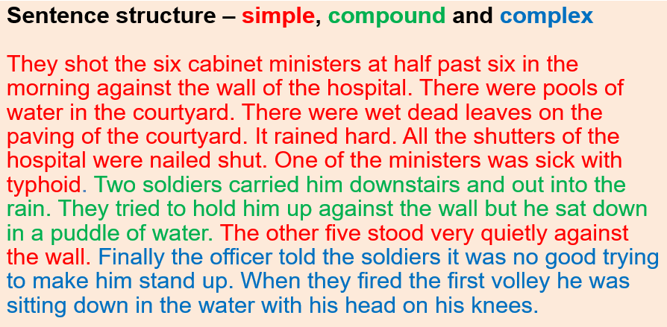

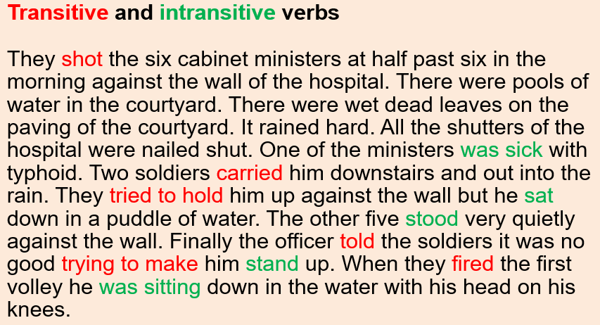

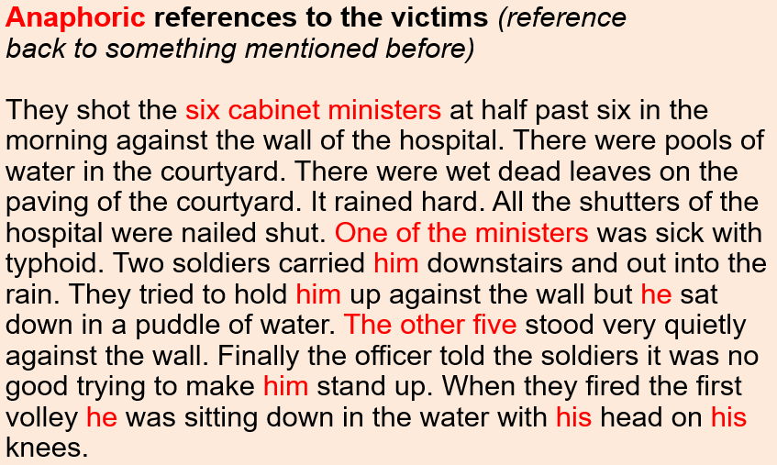

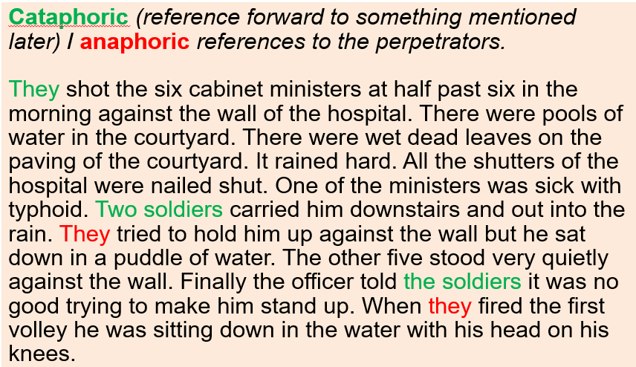

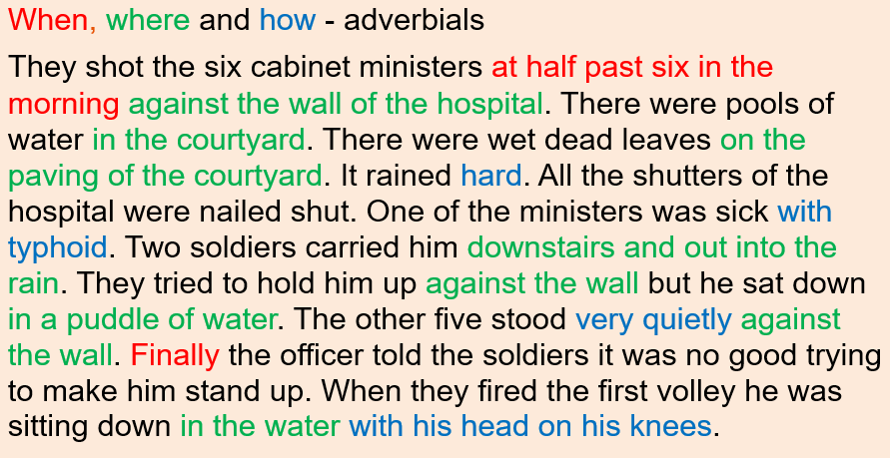

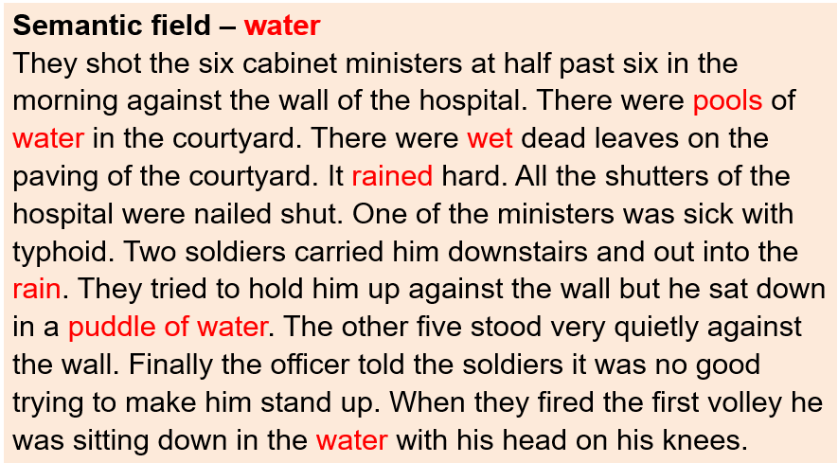

**Analyse and discuss the effect of these grammatical (and lexical) features.** (You might also look at ellipsis, repetition, numbers and adjectives.)

Discussion notes:

………………………………………………………………………………………………………………………………………………

………………………………………………………………………………………………………………………………………………

………………………………………………………………………………………………………………………………………………

………………………………………………………………………………………………………………………………………………

………………………………………………………………………………………………………………………………………………

………………………………………………………………………………………………………………………………………………

………………………………………………………………………………………………………………………………………………

……………………………………………………………………………………………………………………………………………….

………………………………………………………………………………………………………………………………………………

………………………………………………………………………………………………………………………………………………

………………………………………………………………………………………………………………………………………………

………………………………………………………………………………………………………………………………………………

………………………………………………………………………………………………………………………………………………

………………………………………………………………………………………………………………………………………………

………………………………………………………………………………………………………………………………………………

……………………………………………………………………………………………………………………………………………….

………………………………………………………………………………………………………………………………………………

………………………………………………………………………………………………………………………………………………

………………………………………………………………………………………………………………………………………………

………………………………………………………………………………………………………………………………………………

………………………………………………………………………………………………………………………………………………

………………………………………………………………………………………………………………………………………………

………………………………………………………………………………………………………………………………………………

……………………………………………………………………………………………………………………………………………….

**Activity 4a**:

Hopefully you will have developed some thoughts as to how can you use grammar to create and change meaning.

Try rewriting the newspaper report from May 1954 printed in *The Times* (below) in Hemingway’s style.

**ALLEGED ROBBERY OF CAR DRIVER**

**TWO GIRLS SENT FOR TRIAL**

JUNE PATRICIA NICHOLL, aged 21, typist, and IRENE ANN SAMPSON, aged 16, both of

Riggindale Road, Streatham, at South Western Magistrates’ Court on Saturday were sent for

trial at the Central Criminal Court charged with being concerned with a man, not in custody, in robbing Frank Kendall of a brief case and contents, valued at £5, at Tooting Bec Road, and with using violence to him.

Kendall, a retailer, of St. John’s Hill, Clapham Junction, said in evidence that on April 18 at 12.30 a.m. he was driving his car in Tooting Bec Road when the two girls “thumbed” a lift. Nicholl got in by his side and Sampson into a back seat. A man then opened the door by his side and punched him in the face.

At the same time Sampson held his shoulders against the seat while the man continued to punch him about the head. Then he managed to press the button of the hooter, and the man shouted to the girls to run. They ran away, followed by the man. Afterwards, Kendall said, he found that a brief case was missing from the back of the car. On April 21 in Streatham High Road he pointed out the girls to a detective.

Both girls reserved their defence, and were granted bail.

**Activity 4b**:

To practise further, analyse and evaluate the use of language in the text as an example of a news report.

In your response, you should explore:

* the features that are typical of a quality newspaper
* how language is used to report the event.

**Activity 5**:

The text on page 15 is an extract from an advertising insert in the *Daily Express* newspaper promoting holiday offers by the Riviera Travel company.

|  |
| --- |
| **Analyse and evaluate the use of language in the text as an example of a holiday advertisement.**    In your response you should explore:   * the features that are typical of a holiday advertisement * how language is used to promote South Africa. |

To prepare for answering this question, make notes on the language features of this text, particularly the language levels, using the table below:

|  |  |  |
| --- | --- | --- |
| **LANGUAGE FEATURE** | **EXAMPLE** | **EFFECT/MEANING/PURPOSE OF THE FEATURE** |
| **Medium** |  |  |
|  |  |
| **Content** |  |  |
|  |  |
|  |  |
| **Register** |  |  |
|  |  |
|  |  |
| **Lexis and semantics** |  |  |
|  |  |
|  |  |
|  |  |
|  |  |
| **Form and structure** |  |  |
|  |  |
|  |  |
|  |  |
|  |  |
| **Pragmatics** |  |  |
|  |  |
|  |  |

**TEXT: Riviera travel advertisement**

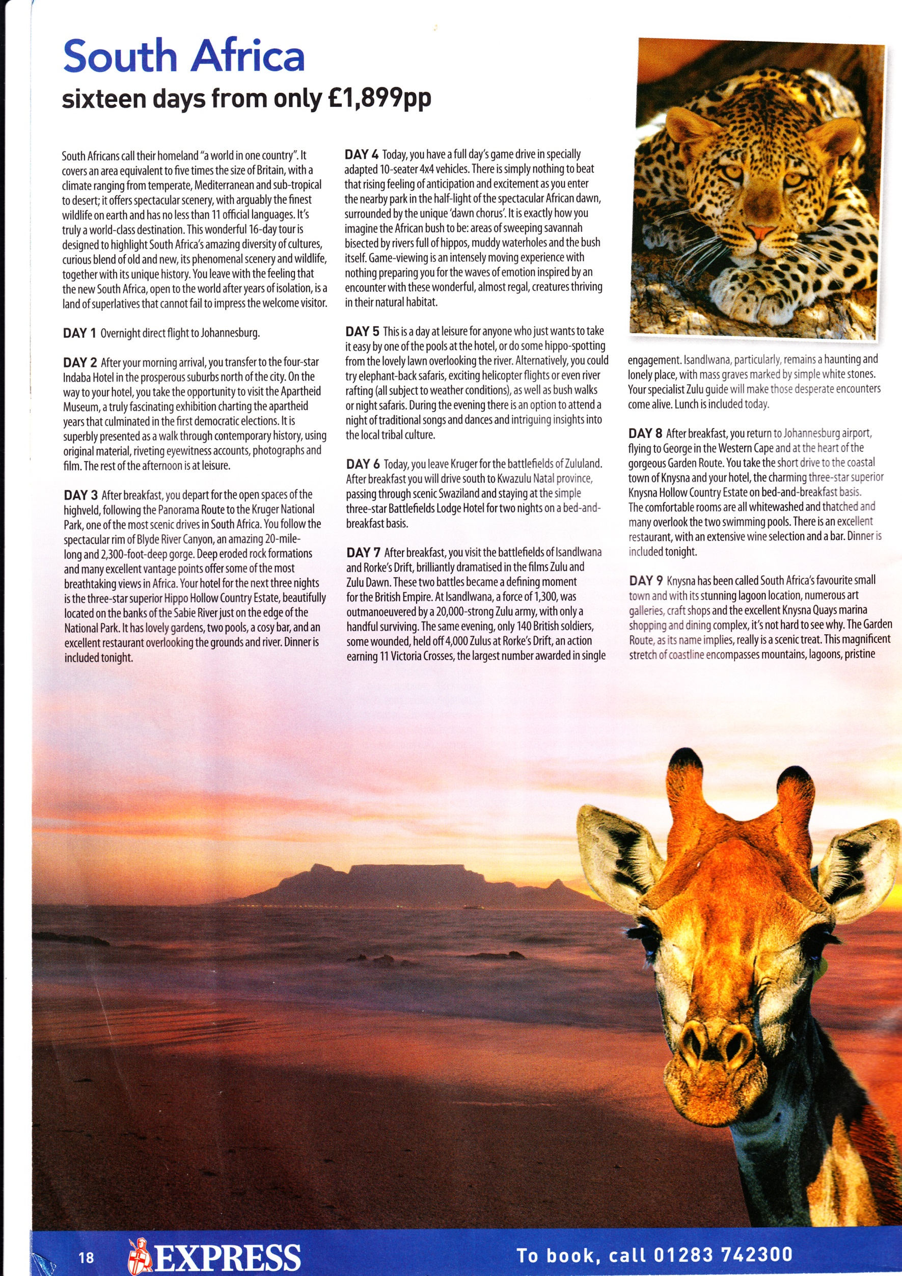**South Africa**  
**sixteen days from only £1,899pp**

**DAY 4** Today, you have a full day’s game drive in specially adapted 10-seater 4x4 vehicles. There is simply nothing to beat that rising feeling of anticipation and excitement as you enter the nearby park in the half-light of the spectacular African dawn, surrounded by the unique ‘dawn chorus’. It is exactly how you imagine the African bush to be: areas of sweeping savannah bisected by rivers full of hippos, muddy waterholes and the bush itself. Game-viewing is an intensely moving experience with nothing preparing you for the waves of emotion inspired by an encounter with these wonderful, almost regal, creatures thriving in their natural habitat.

**DAY 5** This is a day at leisure for anyone who just wants to take it easy by one of the pools at the hotel, or do some hippo-spotting from the lovely lawn overlooking the river. Alternatively, you could try elephant-back safaris, exciting helicopter flights or even river rafting (all subject to weather conditions), as well as bush walks or night safaris. During the evening there is an option to attend a night of traditional songs and dances and intriguing insights into the local tribal culture.

South Africans call their homeland “a world in one country”. It covers an area equivalent to five times the size of Britain, with a climate ranging from temperate, Mediterranean and sub-tropical to desert; it offers spectacular scenery, with arguably the finest wildlife on earth and has no less than 11 official languages. It’s truly a world-class destination. This wonderful 16-day tour is designed to highlight South Africa’s amazing diversity of cultures, curious blend of old and new, its phenomenal scenery and wildlife, together with its unique history. You leave with the feeling that the new South Africa, open to the world after years of isolation, is a land of superlatives that cannot fail to impress the welcome visitor.

**DAY 1** Overnight direct flight to Johannesburg.

**DAY 2** After your morning arrival, you transfer to the four-star Indaba Hotel in the prosperous suburbs north of the city. On the way to your hotel, you take the opportunity to visit the Apartheid Museum, a truly fascinating exhibition charting the apartheid years that culminated in the first democratic elections. It is superbly presented as a walk through contemporary history, using original material, riveting eyewitness accounts, photographs and film. The rest of the afternoon is at leisure.

**DAY 3** After breakfast, you depart for the open spaces of the highveld, following the Panorama Route to the Kruger National Park, one of the most scenic drives in South Africa. You follow the spectacular rim of the Blyde River Canyon, and amazing 20-mile-long andSS2,300-foot-deep gorge. Deep eroded rock formations and many excellent vantage points offer some of the most breathtaking views in Africa. Your hotel for the next three nights is the three-star superior Hippo Hollow Country Estate, beautifully located on the banks of the Sabie River just on the edge of the National Park. It has lovely gardens, two pools, a cosy bar, and an excellent restaurant overlooking the grounds and river. Dinner is included tonight.

The Principal Examiner says:

There will be a range of different approaches to this question, but discussion should focus on the use of persuasive language. Responses should apply appropriate methods of language analysis, and should show critical understanding of the linguistic concepts underpinning advertising. Since AO3 is worth two fifths of the marks for this question, the ways in which contextual factors and language features shape meaning should be addressed.

**Overview of language features**

Typical of any advertisement, the text uses **concrete** and **proper nouns** to establish the ‘product’ on offer, and **positive adjectives**, **superlatives** and **adverbs** to highlight the unique selling points.

There is also a **semantic field** of words associated with tourism (relating to price; hotel star-ratings; familiar collocations etc.). The language is very varied: **formal geographical language** (e.g. *climate, temperate, sub-tropical; highveld, savannah; gorge, rock formations; bisected*); **familiar direct address**; the **language of emotions** (e.g. *breathtaking*, *that rising feeling of anticipation, intensely moving, the waves of emotion*); the **language of politics** (e.g. *apartheid, democratic elections, contemporary history*).

It is designed to **appeal** to and **engage** as many potential customers as possible. In the **telegraphic headline**, the **noun phrases** (the country; the length of the holiday) and **prepositional phrase** (price) immediately highlight **key details**.

The **typography** is designed to make the advertisement easy to read (e.g. large font for the headline; **capitalisation** to mark out the different days of the itinerary; **columns**) and the photograph is eye-catching. These features of the format are visual, designed as a hook to attract a reader’s attention and engage them with the text.

Read through the notes on the following two pages that list the features of interest which may be explored in responding to this question.

Which features did you analyse well?

Which features did you not analyse so well?

**Medium**

* the use of a headline to identify the focus and price
* the use of subheadings to create the feel of an itinerary
* typographical features to attract attention e.g. bold the use of an emotive image—designed to appeal to readers’ interest in exotic wild animals

**Content**

* quotation acts as an overview for what follows i.e. “*a world in one country”*
* semantic field of South Africa e.g. place names, subject specific nouns (*highveld, savannah, waterholes, bush, safaris*)
* semantic field of tourism e.g. *price pp, direct flight, hotel, bar, restaurant* (nouns); *transfer, depart, follow* (verbs), *four-star, three-star* (compound modifiers)
* a mix of facts (e.g. climate, political isolation of South Africa) and opinion (e.g. use of emotive modifiers)

**Register**

* relatively formal tenor e.g. standard English used throughout; polysyllabic lexis; no elision (i.e. *There is*)
* relationship created through second person pronouns (e.g. *You*) and possessive determiners (e.g. *your*) – aims to engage reader in experience described i.e. direct address
* lexis used suggests a specific target audience i.e. people who travel for more than just two weeks in the sun e.g. interested in political history, traditional culture, conservation, unique experience
* BUT also offers both adventurous (e.g. *helicopter flights, river rafting*) and peaceful (e.g. *scenic drives, hippo-spotting*) activities to ensure appeal is broad

**Lexis and semantics**

* proper nouns e.g. location (*South Africa, Kru*), accommodation (*Indaba Hotel*), tourist attractions (*Apartheid Museum*), dramatic geological features of the landscape (*Blyde River Canyon*)
* concrete nouns which create a strong sense of place e.g. natural (*scenery*, *wildlife*, *gorge, hippos*); related to the tourist industry (*hotel, pools, bar, restaurant*)
* abstract nouns e.g. *feeling, opportunity, anticipation, excitement*, *emotion*, *insights* i.e. making this holiday more than just a sequence of events – the audience is engaged in the idea of the visit to South Africa as a life-changing experience
* persuasive adjectives e.g. *wonderful, amazing, phenomenal, spectacular* (emotive – often repeated); *finest, most scenic, most breathtaking* (superlatives); *unique, new, original, superior* (qualitative); *four-star, democratic* (informative); *curious, fascinating, riveting, intriguing* (expressive)
* present tense verbs: dynamic (e.g. *transfer, depart, follow*); stative *(*e.g. *is, has*)
* modal verbs: *cannot fail* (emphatic), *could try* (possibility)
* passive verbs e.g. *is designed, is presented, is included* (agent not important)
* adverbs: *arguably,* *truly* l.6 (attitude); *truly* l.16, *intensely* (intensifier); *superbly, beautifully, specially* (manner); *Alternatively* (linking)

**Form and structure**

* long noun phrases e.g. *a night of traditional songs and dances and intriguing insights*
* the use of complements after the verb ‘to be’ e.g.  *a land of superlatives that cannot fail to impress, an intensely moving experience* (noun phrases in an emphatic position)
* adverbials (often in the form of prepositional phrases) are used frequently e.g. place (*in their natural habitat, by one of the pools*), time (*in the half light of the spectacular African dawn, During the evening*), how long (*for the next three nights*, *for two nights on a bed-and-breakfast basis*)
* fronted time markers e.g. *After your morning arrival, During the Evening* (prepositional phrases), *Today* (adverb) i.e. creating a sense of organisation and careful planning on the part of the company
* listing (persuasive – always offering a range of alternatives) e.g. *amazing diversity …, curious blend … its phenomenal scenery … unique history* (asyndetic); *lovely gardens, two pools, a cosy bar, and an excellent restaurant* (syndetic)
* parenthesis e.g. *open to the world …* (additional information)*, almost regal* (comment)
* sentences are often simple (e.g. *It’s truly a world-class experience*) though not always short (e.g. *This wonderful 16-day tour is designed …; It has lovely gardens …* )
* subordination is often in the form of non-finite *–ing* clauses which provide additional information (e.g. *charting …, using …, following …*)

**Pragmatics**

* advertising insert in the Daily Express (i.e. target audience)
* social implications of accommodation i.e. the lexical choice in the modified noun phrases e.g. *the four-star Indaba Hotel in the prosperous suburbs, the three star superior Hippo Hollow Country Park, the simple three-star Battlefields Lodge Hotel* (i.e. use of modifiers and connotations of proper nouns)
* implicit wider contextual references e.g. South Africa’s history, the cultural implications of apartheid, the importance of conservation and National Parks

|  |  |
| --- | --- |
| Language features I am confident in analysing: |  |
|  |
|  |
|  |
|  |
| Language features I am less confident in analysing: |  |
|  |
|  |
|  |
|  |
| Language features I do not understand: |  |
|  |
|  |
|  |

Read through this example of a Band 3 response to analysing the Riviera travel advertisement. Make notes on its strengths and weakness in preparation for a discussion on how it could be improved.

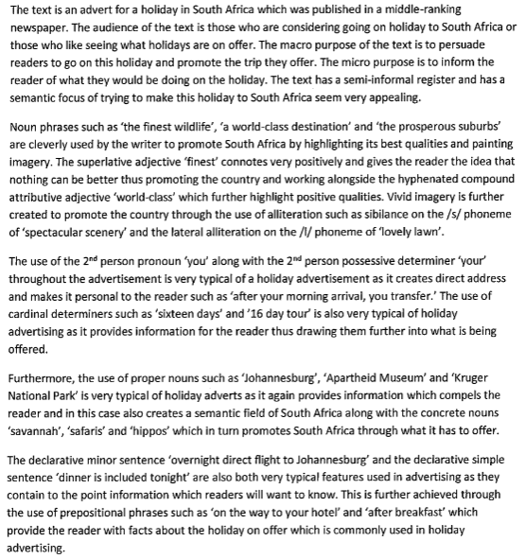

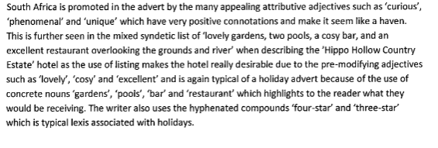

|  |  |  |
| --- | --- | --- |
| **Strengths of the response** | **Weaknesses of the response** | **How it could be improved** |
|  |  |  |
|  |  |  |
|  |  |  |
|  |  |  |
|  |  |  |
|  |  |  |
|  |  |  |
|  |  |  |
|  |  |  |
|  |  |  |
|  |  |  |
|  |  |  |
|  |  |  |

Look at the following page to read the Principal Examiner’s commentary on this response.

The Principal Examiners says:

The candidate’s overview of the text and its contexts is valid. However, it would have been improved had it supported its references to register with relevant illustrations and explanations. References to noun phrases, such as “the finest wildlife…” are sensible, and are relevant to the discussion of the function of the text to promote South Africa as a tourist destination, the focus of the question. The paragraph dealing with pronouns, and determiners (possessive and cardinal) is focused on features of a typical holiday advertisement. However, comments such as “provides information to the reader” are simple and generic and accrue some credit at this level. The same could be said in reference to the candidate’s comment on proper nouns which “provide information”. The candidate demonstrates a secure grasp of grammar when labelling simple and minor sentences correctly. However, the selection of evidence could be more purposeful. In other words, the minor sentence “Overnight direct flight to Johannesburg” is indeed typical of holiday advertisements; but this was perhaps not the most illuminating feature to select for analysis. The final paragraph of the response demonstrates a good grasp of a range of linguistic features. The selection is better here. However, the explanation at the end lacks development.

**AO1: High Band 3**

Sensible and generally sound use of terminology and competent discussion.

**AO2: Low Band 3**

Sound understanding of genre but fails to focus on the “new” South Africa.

**AO3: Low Band 3**

Relevant and generally clear discussion of the construction of meaning.

**Overall: Band 3**

The text below is a newspaper report from May 1954 printed in *The Times*. When this report was published, *The Times* was a broadsheet newspaper (reflecting its size and the quality of its journalism).

Analyse and evaluate the use of language in the text as an example of a news report.

In your response, you should explore:

• the features that are typical of a quality newspaper

• how language is used to report the event.

**ALLEGED ROBBERY OF CAR DRIVER**

**TWO GIRLS SENT FOR TRIAL**

JUNE PATRICIA NICHOLL, aged 21, typist, and IRENE ANN SAMPSON, aged 16, both of Riggindale Road, Streatham, at South Western Magistrates’ Court on Saturday were sent for trial at the Central Criminal Court charged with being concerned with a man, not in custody, in robbing Frank Kendall of a brief case and contents, valued at £5, at Tooting Bec Road, and with using violence to him. Kendall, a retailer, of St. John’s Hill, Clapham Junction, said in evidence that on April 18 at 12.30 a.m. he was driving his car in Tooting Bec Road when the two girls “thumbed” a lift. Nicholl got in by his side and Sampson into a back seat. A man then opened the door by his side and punched him in the face. At the same time Sampson held his shoulders against the seat while the man continued to punch him about the head. Then he managed to press the button of the hooter, and the man shouted to the girls to run. They ran away, followed by the man. Afterwards, Kendall said, he found that a brief case was missing from the back of the car. On April 21 in Streatham High Road he pointed out the girls to a detective. Both girls reserved their defence, and were granted bail.

**Interactive Learning Resources**

On the WJEC Digital Resources site, you will find a range of material written to help you develop your understanding of written language.

Below are links to these resources for you to work through:

* [Travel writing](https://resources.wjec.co.uk/Pages/ResourceSingle.aspx?rIid=2402) - a series of resources to develop understanding of travel writing. The structured interactive tasks prepare learners for travel writing, exploring key features of the genre, its form, potential audiences, and lexical and grammatical choices that convey attitudes and atmosphere.
* [Reviews](https://resources.wjec.co.uk/Pages/ResourceSingle.aspx?rIid=2401) - a series of resources to develop understanding of review writing. The structured interactive tasks prepare learners for writing a review, exploring key features of the genre, its form, potential audiences, and lexical and grammatical choices.
* [Explanations](https://resources.wjec.co.uk/Pages/ResourceSingle.aspx?rIid=2398) - a series of resources to develop understanding of texts that write to explain. The structured interactive tasks prepare learners for writing an explanation text, exploring key features of the genre, and lexical and grammatical choices such as expression, modality and active/passive voice.
* [Opinions](https://resources.wjec.co.uk/Pages/ResourceSingle.aspx?rIid=2400) - a series of resources to develop understanding of opinion writing. The structured interactive tasks prepare learners for writing an opinion piece, exploring key features of the genre, its structure, rhetorical devices, and lexical and grammatical choices including emotional appeal and tone.
* [Obituaries](https://resources.wjec.co.uk/Pages/ResourceSingle.aspx?rIid=2399) - a series of resources to develop understanding of obituary writing. The structured interactive tasks prepare learners for writing an obituary, exploring key features of the genre, its form and structure, and lexical and grammatical choices such as expression and sentence structure.

**KEY TERMS AND THEIR DEFINITIONS GLOSSARY**

**TERM DESCRIPTION**

abstract noun A noun that denotes a concept or thing with no physical qualities e.g. *courage, welcome, doom*.

accelerando A term used to describe speech that is getting faster (marked *accel* on transcripts).

accent The distinctive manner of pronouncing language associated with a particular region, social group etc.

acceptable A term used to describe any language use that native speakers feel is allowed.

accommodation A term used to describe the changes people make to their speech, prosodic features and gestures in order to emphasise or minimise the differences between them.

acronym An abbreviation formed by taking letters from a series of words, which is pronounced as a word e.g. *radar, NATO, LOL*.

active voice A grammatical structure in which the subject is the actor in a sentence e.g. *The dog chewed the bone*.

adjacency pair A sequence of two connected utterances by different speakers one after the other. This may take a range of forms: question/answer; greetings; complaint/explanation or remedy; statement/affirmation; command/action etc. e.g. *Shut the window*. → *Sure*.

adjective A word that defines attributes of a noun and that can occur before the noun (e.g. *the red tulip*) or after a stative verb (e.g. *the tulip was red*), and can often express contrasts (e.g. *the smaller flower was reddest*).

adjective phrase A group of words with an adjective as the head e.g. *really quick, amazingly scary to do*.

adjunct An adverb that provides more information about a verb, answering the questions when? how? where? e.g. *The baby often* (time) *sleeps fretfully* (manner) *upstairs* (place).

adverbial A clause element which provides additional information about time, manner, place and reason in a sentence e.g. *He will come today*. (noun); *He will come up the mountain*. (prepositional phrase); *He will come because he is desperate*. (subordinate clause).

adverbial clause A dependent clause introduced by a subordinating conjunction such as *after, since, when, as, because*, which functions as an adverbial element within a sentence e.g. *We left in the morning as soon as it was light*.

adverb phrase A group of words with an adverb as the head e.g. *very quickly, too quickly for comfort, more quickly than I cared for*.

adverb A word that defines the action of a verb (e.g. *the rain fell heavily*), that can act as an intensifier (e.g. *really loud*), that can express contrasts (e.g. *more crucially, most crucially*), and that can function as a sentence connector (e.g. *Nevertheless, I would not be voting for the candidate after that*).

affix A bound morpheme which is used to form a new word e.g. *declutter, beautiful*.

agreement A term used to describe the relationship between words (also called concord).

**TERM DESCRIPTION**

alliteration A term to describe the repetition of consonants or consonant clusters at the beginning of words in close proximity e.g. *Conservatives on course to conquer after commentators got it wrong*.

ambiguity A term used to describe language with multiple meanings e.g. *Police looking into Sinkhole* i.e. investigating (‘looking into’ = multi-word verb) OR looking (‘into Sinkhole’ = prepositional phrase of place).

anaphoric reference A term to describe referencing in which a pronoun points backwards to an earlier noun phrase e.g. *The storm caused devastation. It felled trees, ripped tiles from roofs and demolished garden fences*.

antithesis A rhetorical device which sets two contrasting ideas in opposition—there will often be grammatical patterning to draw attention to the linked ideas e.g. *It was the best of times, it was the worst of times* …

antonyms Words that are opposite in meaning or associations e.g. *foreign/local, winter/summer*.

apposition A noun phrase, separated from the rest of the sentence with commas, dashes, or brackets, which elaborates on the noun phrase preceding it e.g. *The Daily Mail, a tabloid with a strong Conservative ideology, described Cameron’s election results as a “stunning outright victory”*.

appropriate A term used to describe any language use that is seen as suitable for the context in which it is used.

archaic A term describing lexis, syntax or orthography that is no longer used.

aspect The timescale of the action expressed by the verb phrase, which may be complete (perfective) or ongoing (progressive).

assimilation In phonology, the way in which the sounds of one word can change the sounds of neighbouring words in connected speech.

assonance A term used to describe the repetition of vowel sounds e.g. *Old age should burn and rave at close of day/Rage, rage, against the dying of the light*.

asyndetic A term used to describe a list of words, phrases or clauses that are not connected by a conjunction e.g. *I believe in government of the people, by the people, for the people*.

attributive A term used to describe modifiers that precede the noun they are describing e.g. *an unsatisfactory result*.

auxiliary verb A verb that precedes the lexical verb in a verb phrase e.g. *I do believe in fairies. He may visit. Do you want to come? Peter has finished the book. The rain was falling all day. She did not run yesterday*.

back channelling Interactive features such as minimal responses (e.g. *mm, yeah, ahh*) that demonstrate a participant is listening and paralinguistic features (e.g. laughter) that show affirmation, but which do not disrupt the speaker’s turn.

back-formation A process for forming words in which an affix is removed from an existing word creating a new word in a different word class e.g. *babysit* (verb) from *babysitter* (noun).

base The minimal form of a word to which affixes can be added.

bi-nomial pair An expression containing two words joined by a conjunction (usually *and/or*), often with a fixed order (collocation) e.g. *scream and shout, make or break, hustle and bustle*.

**TERM DESCRIPTION**

blend A word formed by combining two or more words to create a new word combining the meaning of the originals (also called portmanteau words) e.g. *webinar → web + seminar*.

borrowing Introducing a loan word from one language into another.

bound morpheme A prefix or suffix that can only occur attached to a free morpheme e.g. *unhappy, driver, cars, exchange*.

cardinal number The basic form of a number e.g. *one, ten, three thousand*.

caretaker speech The distinctive speech adults use when they talk to young children.

cataphoric reference A term to describe referencing in which a pronoun points forwards to a later noun phrase e.g. *He’s ahead of the pack. And it’s Many Clouds still at the front and over the last fence now*.

clause A group of phrases which usually has a tensed verb phrase

cliché An image that has lost its original meaning or novelty through overuse e.g. *only time will tell, frightened to death, the quiet before the storm*.

clipping The creation of a new word with the same word class and denotation by dropping a syllable (also called truncation) e.g. *Thurs, spec, flu, phone*.

closed class A group of words with a grammatical function (e.g. determiners, pronouns, prepositions and conjunctions) to which new words are rarely added.

cleft sentence A sentence which has been rearranged with a dummy subject *it* + *to be* followed by the focus of the sentence and a relative clause e.g. *It is school traffic that slows everything down on a weekday*.

cohesion Linguistic connections which link elements of a discourse.

coinage The construction and addition of new words to the word stock.

collective noun A noun that refers to a group, which may take a singular or plural verb form depending on whether the group is seen as a single cooperative body or a collection of individuals.

collocation A recognisable group of words that frequently occur together e.g. *there you go*.

colloquialism An informal word, phrase or pronunciation, often associated with informal speech.

comment clause A commonly occurring clause in speech which adds a remark to another clause e.g. *I mean …, I think ...*

comparative A form used for comparisons of adjectives or adverbs e.g. *colder, more ludicrous* (adjectives); *more calmly* (adverb).

complement A clause element that adds extra information about the subject after a copula verb (e.g. *The skylark’s song was memorable*.) or the object (e.g*. I painted the wall purple*.)

complex sentence A sentence made up of one main clause and at least one subordinate clause e.g. *Choosing stone for the garden wall* (subordinate clause) *was* (main clause verb phrase) *very complicated because there were so many options in the garden centre* (subordinate clause).

compound A word or phrase made up of at least two free morphemes e.g. *wallpaper, small-talk*.

**TERM DESCRIPTION**

compound-complex A sentence made up of at least two coordinated main clauses and at least one subordinate clause e.g. *The car park was full* (main clause) *because there was building work* (subordinate clause), *but it made no difference to the shoppers* (main clause) *who were determined to get what they had come for* (subordinate clause).

compound sentence A sentence made up of at least two main clauses linked by a coordinating conjunction e.g. *The sky was dark* (main clause) *and the wind whipped our hair* (main clause).

concrete noun A noun that refers to physical things like people, places, objects and substances.

conjunct An adverb that has a linking function e.g. *nevertheless, however, instead*.

conjunction A closed class word used to join other words or phrases together e.g. *bread and butter pudding* (coordinating); *I liked her since she was always ready to help* (subordinating).

connotations The associations linked to a word that go beyond its denotation.

consonant cluster A group of consonants occurring at the beginning of a word e.g. *stream, thread, plot*.

context The circumstances (social, historical, geographical, cultural, physical) in which speech and writing take place.

contraction A shortened word e.g. *can’t, won’t, we’re*.

convergence A process in which two speakers adapt their language and pronunciation to reduce the difference between them.

coordinating conjunction A word that joins words, phrases, clauses or sentences of equal grammatical status e.g. *and, or, but*.

copula verb A verb that is followed by a complement e.g. *be, seem, appear, grow, become*.

count noun A noun that refers to things that can be counted, and which has a plural form e.g. *computer/computers*.

declarative A grammatical mood where the subject is followed by the verb in a sentence which expresses a statement e.g. *The balloon flew over the mountain*.

degree adverb An adverb which indicates the extent of a quality e.g. *very, really, quite, nearly, so*.

deixis A term describing expressions that rely on the context for interpretation e.g. *there, over here, that high*.

demonstrative A term used to describe pronouns and determiners that distinguish between similar items e.g. *this/that, these/those*.

denotation The dictionary meaning of a word.

deontic modality A modal verb expressing ability, necessity or obligation e.g. *can, could, may, must, shall, should*.

dependent clause A clause which cannot stand alone (also called subordinate clause).

derivation A term to describe words that are formed by adding affixes to create new words e.g. *slow + ness, arriv(e) + al, simpl(e) + ify*.

descriptive An approach to language based on observation of language in use, focusing on appropriateness and acceptability rather than on making judgements.

**TERM DESCRIPTION**

determiner A closed class word which only occurs at the beginning of a noun phrase and which defines the number and definiteness of the noun e.g. *the dog, some flowers, a mistake, that list*.

dialect A language variety with distinctive lexis and grammar used by speakers with common regional, social or cultural backgrounds.

dialect levelling The reduction in differences between dialects caused by language contact and mass media.

direct object A clause element that is directly affected by the action or process of the verb e.g. *The racing-driver crashed the car*.

direct speech A form of speech in which the actual words spoken are recorded, usually between speech marks e.g. *He looked down at the floor and muttered, ‘Well, it wasn’t my fault.’*

discourse Any spoken or written language longer than a sentence.

discourse markers Words or phrases that stand outside the clause and act as fillers, topic changers, hedges etc. e.g. *well, right, y’know, I mean, basically*.

disjunct A sentence adverb allowing the speaker or writer to comment on the content or style of a sentence e.g. *honestly, fortunately for you, clearly*.

divergence A process in which two speakers adapt their language and pronunciation to increase the difference between them.

double negative A structure in which more than one negative particle is used in a single verb phrase e.g. *He didn’t never tell lies.*

dummy word A word which fills a grammatical function in a clause, but which has no meaning e.g. *It is Jack who should be apologising. Do you want a cup of tea*?

dynamic verb A verb which expresses an action rather than a state and which has a progressive form e.g. *I was picking apples*.

-*ed* participle A nonfinite verb formed by adding an *–ed* inflection to the base of regular verbs (or which has an irregular form), which occurs with an auxiliary in a tensed verb phrase, or by itself as a nonfinite clause (also called a past participle) e.g. *The girl (had swum) for miles. The window broken by the stone (had been repaired).*

elision The omission of sounds in connected speech.

ellipsis The omission of part of a sentence that can be understood by the context. e.g. *The sprinter had broken the world record, Ø reached a new PB and Ø charmed the crowds*.

embedded clause A subordinate clause which functions as a part of a clause element e.g. *The fireworks which lit up the sky had cost a fortune* (post-modifying subject noun phrase). *They had done enough to achieve victory* (post-modifying object noun phrase).

emphatic stress Emphasis placed upon syllables or words in spoken discourse

enclitic An unstressed morpheme which joins phonetically to the preceding word e.g. *don’t, I’d.*

end focus The positioning of information at the end of a clause for emphasis

enjambement The overlapping of meaning from one line to another in verse without punctuation.

enumerators Cardinal and ordinal numbers.

**TERM DESCRIPTION**

epistemic modality A modal verb expressing a speaker’s assessment of the reality or likelihood of an event taking place e.g. *can, may, might, must, should, will, would*.

etymology A study of the origins and history of words.

euphemism A word that replaces another which is seen as taboo or social unacceptable.

exclamation The tone communicated by the use of an exclamation mark e.g. *We were only joking!*

exclamative A sentence beginning with how or what in the initial position to communicate strong feelings e.g. *what an insult!; how unbelievable is that!*

existential ‘there’ A sentence in which *There* is used as a dummy subject with a delayed subject occurring after the verb to be for emphasis e.g. *There was litter everywhere*.

exophoric reference A term to describe referencing in which a lexical item points to the wider linguistic context e.g. *That man there is my brother*.

false start An utterance that is started, left incomplete, and then restarted with a different grammatical structure e.g. *and Si.. Glen Johnson; they are (.) it’s impossible; I felt that it (.) people were everywhere*.

field An area of meaning linked to the subject matter of a discourse (e.g. physics) which will contain linked lexical items e.g. *gravity, relativity, spacetime, Einstein, Newton, density gradient*.

figurative language A term used to describe any language use that is non-literal, using devices such as metaphors, similes etc. to create poetic and descriptive effects.

filled pause A voiced hesitation in spoken language.

filler Words, usually with no semantic value, which are inserted into speech either from habit or to give a participant thinking time as they search for a word e.g. *er, um, ah*.

finite A term used to describe verb phrases marked for tense, person and number.

foregrounding A change in the order of clause elements to draw attention to a particular linguistic item (also called fronting) e.g. *In winter, I’m really moody*.

form The class of a word or the type of phrase.

free morpheme The smallest meaningful unit of language that can occur by itself.

function The role of words, phrases or clauses within a sentence e.g. modifiers in a noun phrase.

function word Closed words like prepositions, conjunctions, determiners etc. that express grammatical functions within a sentence.

future time A verb phrase that indicates actions/processes that have not yet taken place using the modal will, the multi-word verb *to be + going to*, or the simple present in subordinate clauses.

gradable A term to describe adjectives and adverbs that can be compared (e.g. *colder, coldest*) or intensified (e.g. *so cold*).

grammatical mood A term describing the relationship between the verb phrase and the intention of a sentence e.g. making a statement (declarative); asking a questions (interrogative); telling someone to do something (imperative); communicating something hypothetical (subjunctive).

head word The main linguistic item in a phrase.

hedging The use of mitigating words or sounds to lessen the impact of an utterance e.g. *I think, I’m not an expert but …, somewhat, it’s possible that …*

**TERM DESCRIPTION**

hesitation The repetition of the initial sound of a letter e.g. *s. straight; th. um (.) the very obvious*.

homonym Words with the same sound and form but different meanings e.g. *rock* (noun, aggregate of solid mineral matter) and *rock* (verb, move gently back and forwards).

homophone Words with the same sound but different spelling and meaning e.g. flower/flour.

hyperbole Exaggeration or overstatement used as a rhetorical device to heighten feelings.

hypercorrection A process of overcompensation where speakers use non-standard forms in the belief that they are more formal or correct e.g. *She gave it to John and I*.

hypophora A rhetorical device in which a speaker or writer poses a question and then provides the answer.

idiolect A term used to describe the characteristic speech of an individual, including distinctive features of pronunciation, lexis, and grammar.

idiom A distinctive expression in which the meaning is not a literal interpretation of the individual words e.g. *She jumped the gun when she sent in that complaint yesterday*. i.e. ‘acted too fast’.

imperative A grammatical mood expressing a directive using a verb in the base form with no subject e.g. *Sit. Don’t eat it. Stop*.

implicature A term used to describe what a hearer infers from an utterance.

inclusive A term used to describe a first person plural reference (e.g. *we, us*) that includes the speaker as well as the addressee(s).

independent clause A clause that can stand alone, has a tensed verb phrase, and makes sense by itself (also called a main clause).

indirect object The animate being that receives the action of the verb, which comes before the direct object, or after it in the form of a prepositional phrase e.g. *The cat brought Sandra a mouse* OR *The cat brought a mouse to Sandra*.

indirect speech A form of speech which reports what someone else has said, where the subordinator that introduces words spoken e.g. *The teacher said that I could pass*.

infinitive A non-finite base form verb which usually occurs with the preposition to e.g. *to sit*.

inflection The marking of a grammatical relationship with a suffix e.g. plural and possessive nouns, verbs participles (-*ing*, -*ed*).

-ing participle A non-finite verb formed by adding an -*ing* inflection to the base form of a verb, which occurs with an auxiliary in a tensed verb phrase, or by itself as a non-finite clause (also called a present participle) e.g. *The girl was crying for ages. The leaves falling from the trees carpeted the ground*.

initialism A word formed from the first letters of a sequence of words pronounced letter by letter e.g. *NHS, BBC, OMG*.

initial position A term used to describe the first site in a sentence, clause, phrase or word. intensifier An adverb that adds emphasis e.g. *so, very, really*.

interactive feature Distinctive non-verbal utterances that affirm (e.g. *mm, yes*), show agreement (e.g. feature laughter), add reinforcement (e.g. echo utterances).

**TERM DESCRIPTION**

interjection A closed class group of words and phrases that communicate emotions or spontaneous responses which are not part of the grammatical structure of a clause e.g. *hey!, oh dear!*

interrogative A grammatical mood expressing a question, in which the subject and the verb are inverted e.g. *Has she got a cat? Would they buy a book? Does he want to come?*

interruption The ending of one speaker’s turn by the intervention of another speaker, which may be a non-cooperative challenge, or may be the result of multiple participants with equal status in a conversation.

intonation The quality or tone of voice in speech, which can stay level, rise or fall.

intransitive A verb which requires no object to complete its meaning (e.g. *The baby smiled*.)—some verbs can be both intransitive (e.g. *The family ate*.) and transitive (e.g. *The family ate the meal*.)

irony A way of writing or speaking in which the intended meaning appears to be the opposite of what is actually said e.g. *Thanks so much for taking the bins out!* (i.e. bins have not actually been taken out = implicit criticism).

latch-on A smooth link between different speakers in a spoken exchange.

lexical cohesion Links created between words as a result of their related meanings.

lexical diffusion The gradual spread of linguistic change.

lexical set A group of words linked by a common word class, which may also have related meanings.

lexical verb The verb in a verb phrase that carries the main meaning (also called a main verb) e.g. *The man fell. The children had finished. The car should have arrived by now*.

lexis The term used to describe the vocabulary of a language.

liaison A process that changes the pronunciation of words at boundaries, usually inserting /*r*/.

loan word A word borrowed from another language e.g. *tortilla*.

main clause A clause that can stand alone, has a tensed verb phrase, and makes sense (also called an independent clause)

malapropism A misuse of words that sound similar e.g. *fire distinguisher* for *fire extinguisher*.

marked theme A linguistic unit that occurs at the front of a sentence replacing the subject (the theme of a sentence) e.g. *In the middle of winter, you don’t expect crocuses to flower*.

metaphor A figurative use of language in which one thing is seen in terms of something else e.g. *He was at a crossroads and didn’t know which road to take* (= making choices in life).

metonymy The use of an attribute to represent the whole e.g. the *stage* = *theatre*.

minimal pair/set Two or more words that are identical except for one phoneme occurring in the same place which changes the meaning e.g. *pin/pan, shot/pot, din/dip/did/dig*.

minor sentence A sentence or utterance that lacks one or more of the clause elements (e.g. *three samosas*—said to a server on the deli counter), often formulaic in structure (e.g. *Sure!*—in response to a question).

**TERM DESCRIPTION**

modal verb An auxiliary that alters the meaning of the lexical verb in terms of likelihood, ability, permission, obligation etc. e.g. *we must go* (obligation); *we might go* (possibility); *we will go* (prediction).

mode A term used to describe whether language use is written, spoken, or multi-modal.

modifier A word used to add descriptive detail to another word e.g. *the slow train; the train screeched wildly*.

monitoring features Expressions which allow a speaker to check that the hearer is still listening, has understood etc. e.g. *if you remember …, would you believe … , you know*.

monosyllabic Having one syllable.

morpheme The smallest unit of meaning e.g. *dog* (free); *re-* (bound).

morphology The study of the structure of words in terms of morphemes.

multi-word verb A verb which has a particle e.g. *the police kicked in the door* (verb + adverb = phrasal verb); *the girl looked at the painting* (verb + preposition = prepositional verb).

negative The use of particles or words to deny what is asserted by a verb e.g. *The tree has not grown. The child never sat down. I ate nothing*.

neologism The creation of a word from existing lexical items e.g. *electracy*—the skills and facility needed to make full use of the communicative potential of new electronic media (modelled on ‘literacy’).

non-count noun A noun referring to things which cannot be counted and which often do not have a plural form e.g. *traffic, applause*.

non-finite verb Verb forms that are not marked for tense, person or number e.g. base forms, infinitives, -*ing* (present) and –*ed* (past) participles.

non-finite clause A dependent clause introduced by a non-finite verb, which can function as a postmodifier (e.g. *The family running for the bus were clearly late*.) or as a clause element (*Deprived of love, pets don’t thrive*.)

non-standard Language that does not conform to the standard prestige form which is used as a linguistic norm.

noun An open class word with a naming function, often with a plural form and which can be marked for possession.

noun clause A dependent clause introduced by the subordinating conjunction that, which can fulfil the subject site (e.g. *What I want is time to rest*.), the object site (e.g. *I believe that the tide is coming in*.) or the complement site (e.g. *My one hope in life is that I do something useful*.) of a clause.

noun phrase A phrase which usually has a noun as its head, that can function as a subject, object, complement or adverbial in a clause.

normal non-fluency Commonly occurring features of spoken language such as hesitations and false starts which break up the flow of speech.

obsolete words Words that are no longer in use e.g. *jargogle*: to confuse or jumble; *scuppet*: a spade used for making ditches.

onomatopoeia The term used to denote words that imitate sounds e.g. *splash, murmur, clank, buzz*.

open class A large group of words (nouns, adjectives, verbs and adverbs) to which new words can be added—they carry the main meaning in a sentence (also called lexical words).

**TERM DESCRIPTION**

ordinal number Numbers that indicate the order of a sequence e.g. *first, second, third*.

orthography The study of spelling and the ways letters are used in a language e.g. spelling rules, hyphenation, capitalisation, word breaks, punctuation.

overlap Participants speak at the same time, but the dominant speaker’s turn is not ended—this can mark positive feedback where one speaker provides backchannel affirmation or support; the misjudgement of the end of a turn; or an additional point or comment on what is being said.

oxymoron The use of apparently contradictory words in a phrase e.g. *eloquent silence, darkness visible*.

paralinguistics The study of non-verbal communication e.g. vocal effects (laughing, sighing), gesture, posture and facial expressions.

parallelism Patterning of pairs of sounds, words, or other structures to create a sense of balance e.g. *quickly and decisively*, *neither a poet nor a philosopher*.

parenthesis The use of brackets, dashes or commas in written language, or pauses in spoken language, to mark out an optional element of a sentence or utterance.

passive voice A grammatical structure in which the subject and object change places to alter the focus of a sentence and the verb phrase is made up of to *be + -ed* participle e.g. *The book was written (by a local woman)*.

pauses Breaks in spoken language which can be minimal (micro pause), often marking the end of utterances, or timed (in seconds) e.g. *we’ll stop there (.) let’s try to (2) meet up later*.

perfective An aspect made up of *to have + -ed* participle e.g. *the cat has caught a mouse* (past action with present relevance); *the cat had caught a mouse* (action completed before a specific time).

periphrastic A grammatical structure formed by a combination of words rather than by inflection e.g. *the man did go/the man went* (past tense); *the vote of the people/the people’s vote* (possessive).

personification A device in which something non-human is given human attributes e.g. *the blushing birds*.

phatic speech Words, phrases and clauses that have a social function e.g. *good morning; lovely day; thanks*.

phonemes The smallest unit of sound.

phonetics The study of spoken sounds and the way in which they are produced.

phonology The study of sounds in a particular language and the ways in which they are combined to create meaning.

phrase A group of words that has no finite verb (except for a verb phrase) e.g*. a sleeping dog* (noun); *very clear blue* (adjective); *really soon* (adverb); *is going* (verb).

polysyllabic Having more than one syllable.

post-modification Lexical items that follow the head in a phrase e.g. *the horse that bites; very happy to see you*.

pragmatics The study of how contextual factors influence a speaker’s or writer’s language choices.

predicative The term used to describe modifiers that follow a copula verb e.g. *the grass was long.*

**TERM DESCRIPTION**

predicator The verb phrase filling the verb site of a clause e.g. *the dog was running up the mountain.*

prefix A bound morpheme that can be added to the beginning of a free morpheme e.g. *redo*.

pre-modification Lexical items that precede the head in a phrase e.g. *quite sad; apple tree*.

preposition A closed class word which comes in front of a noun phrase to express a relationship e.g. *on the mountain; under the table*.

prepositional phrase A phrase made up of a preposition and a noun phrase which can function as a postmodifier (e.g. *the dog with a fluffy tail*) or as an adverbial (e.g. *the man walked along the river*).

prescriptive An approach to language that dictates rules of usage, and which focuses on concepts of ‘right’ and ‘wrong’.

proclitic An unstressed morpheme which joins phonetically to the following word e.g. *’twas, ’tis.*

progressive An aspect made up of *to be + -ing* participle e.g. *the dog is chasing a rabbit* (ongoing action in the present); *the dog was chasing a rabbit* (ongoing action in the past).

pronoun A closed class word that can replace a noun phrase e.g. *the boy → he*.

proper noun A noun that refers to the names of specific people, place and occasions, and which has an initial capital letter in written language e.g. *December, Eid, River Bann*.

prosodic features The use of pitch, volume, pace and rhythm to draw attention to key features of spoken language.

quoted clause A clause containing the actual words spoken in direct speech and usually marked with speech marks in written language e.g. *‘He’s behind you,’ chanted the audience*.

quoting clause A clause accompanying direct speech that tells us who has said something e.g. *‘He’s behind you,’ chanted the audience*.

rallentando A term used to describe speech that is getting slower (marked *rall* on transcripts).

Received pronunciation An accent which has high social status and is not connected to a specific region (also known as RP).

relative clause A dependent clause introduced by a relative pronoun such as that, which, whoever, whom, of which, which post-modifies a noun phrase e.g. *the artist whose work was on display entered the room*.

register A style of language used in a particular context defined in terms of mode, tenor and field.

repertoire An individual’s range of spoken and written forms.

rhetorical question A question that does not require an answer.

self-correction A speaker’s repair to an utterance e.g. *bret-ta. (.) breathtaking; Steve (.) Sir Stephen*.

semantic change Changes in word meaning over time.

semantic field A theme or topic created by the use of words with associated meanings e.g. *doctor, medicine, vaccinating, surgery, prescription*.

**TERM DESCRIPTION**

sentence A grammatical structure made up of one or more clauses, marked by a capital letter and a full stop in written language (called an utterance in spoken language).

simile A device which makes a direct comparison between two things using the prepositions *like* or *as* e.g. *her heart was beating like the wings of bird against its cage*.

slang Distinctive, and often short-lived, words and phrases used by clearly defined social or age groups associated with informal speech e.g. *cork it* (stop talking).

simple sentence A sentence made up of one main clause e.g. *The astronaut fastened his belt*.

spontaneity markers Distinctive features of spoken language that mark speech as spontaneous and unscripted, including comment clauses, fillers, hesitations etc.

standard The form of a language considered to be the norm and used as the medium of education, government, and the legal system.

stative verbs Verbs that express states of being or processes, which rarely take a progressive form e.g. understand, wish, doubt.

subject A noun phrase or a clause which is the actor of a sentence e.g. *Winning medals is the goal of all athletes. The builder plastered the wall quickly*.

subjunctive A grammatical mood used to express something hypothetical or tentative—most common now in formulaic expressions (e.g. *God save the Queen*.) and in *If* structures (e.g. *If I were Prime Minister …*.)

subordinate clause A clause that cannot stand alone, but needs another clause to complete its meaning e.g. *Because I was tired, I went to bed early*.

subordinating conjunction A conjunction used to introduce a subordinate clause e.g. *while, as soon as, althou*gh e.g. *I couldn’t finish cutting the grass until the rain stopped*.

suffix A bound morpheme that can be added at the end of a free morpheme e.g. *goodness*.

symbol A device in which a word or phrase represents something more than itself e.g. *fog* can be symbolic of confusion

syndetic A term used to describe a list of words, phrases or clauses that are connected by a conjunction e.g. *A dove, a red rose, a rainbow and a kitten are all positive symbols*.

synonyms Different words that have the same or similar meanings e.g. *repulsive, nauseating, disgusting*.

syntax The study of the grammatical relationships between words in sentences.

tag question An interrogative structure that is attached at the end of a statement to encourage a reply e.g. *It’s good, isn’t it? I don’t like it, do you?*

tenor The relationship between participants in a language interaction.

tense A change in the form of a verb to indicate timescale e.g. *he walks* (present); *he walked* (past).

transitive A verb which requires an object to complete its meaning e.g. *The baby ate a banana*.— some verbs can be ditransitive (e.g. *Uncle Andrew told the children a story*.)

turn-taking The organisation of participants in a spoken interaction, where the turns may be equal or where one speaker may be dominant.

**TERM DESCRIPTION**

tripling Patterning of words, phrases, clauses or sentences in recognisable groups of three e.g. *No birdsong. No wind in the trees. No sign of life*.

utterance A grammatical structure made up of one or more clauses, often preceded by a micro pause and followed by another pause or a change of speaker in spoken language (called a sentence in written language).

unintentional repetition The accidental repetition of a monosyllabic word in spoken language e.g. *they they’ve; we we we*.

verbal noun A noun derived from a verb e.g. *Sewing is a useful skill*.

verbless clause A clause that contains no verb although the structure implies there should be one e.g. *When in doubt, ask*.

verb An open class word expressing states, process and actions, which can be marked for tense, aspect, voice and modality.

verb phrase A phrase made up of a single lexical verb, or up to four auxiliaries and a lexical verb e.g. *follows, was following, should have been following, may have been being followed*.

vocative The term of address used to refer directly to a person in speech e.g. *Come over here, John*. *Prime Minister, I’m very pleased to meet you*.

wh- question Questions introduced by *wh*- question words, which expect new information in the answer e.g. *Why are you late?* → requires reason.

word formation The process of creating words from free and bound morphemes e.g. *un + gracious + ly*

word order The arrangement of words, phrases and clauses in a sentence.

yes/no question Questions marked by the inversion of subject and, which require an affirmative or negative response e.g. *Is this dress alright?* → requires yes/no.