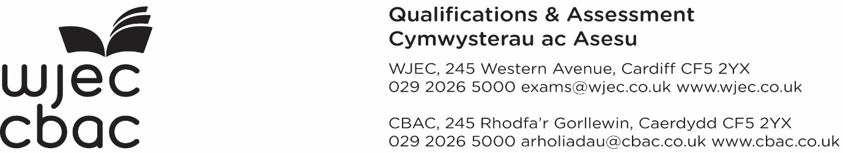

|  |  |
| --- | --- |
| 🕿 Direct / Uniongyrchol |  |
| **Circular No. 61** |  |
|  | Our reference / Ein cyfeirnod |
| MF/LG/Circ.No.61 |
| Contact / Cysylltwch â |
| GCSE |
|  |
| Date / Dyddiad |
| February 2020 |

Dear Sir/Madam

**GCSE MFL Unit 1 Speaking assessments - information for centres**

**Set allocations for candidates and Modified Paper (WJEC)**

The list allocating a set number to each candidate for the GCSE MFL Speaking assessments can be accessed on the secure website from Monday 23rd March 2020.  Please note that this information is confidential and must not be shared with candidates prior to the assessment.

Select the blue tab at the top of the secure website landing page entitled ENTRIES and scroll down the menu to find GCSE MFL – Set Allocation.  Select the session, paper (language and tier) to view the set allocation list for your candidates.  When you press the PDF icon to print out the list, the teacher examiner and the candidate authentication forms will also be printed.  The printed information must be stored confidentially and securely until required for the Speaking assessments.

Further details will be available in the E-submission guide.

Centres who have requested Modified Papers for candidates will only receive the modified oral cards allocated to the candidate/s.

Centres are advised that WJEC has produced a form for candidates to consent to their work for Unit 1 to be used with teachers and examiners for standardising purposes. Please find attached the candidate permission cover sheet, which can also be found on the WJEC GCSE MFL webpages. Once completed, this should be scanned and uploaded onto Surpass along with teacher examiner/candidate authentication forms and set allocation lists.

Yours faithfully

**ELAINE CARLILE**

Director of Assessment Delivery

GCSE FRENCH / SPANISH / GERMAN

UNIT 1 SPEAKING

**GDPR Consent**

**Candidate to Complete**

* WJEC may select your work for use at teacher training events and subsequently upload it onto WJEC's secure website (accessible only to teachers via a secure login). Your name would be removed from your work before we use it. All materials are reviewed regularly and are removed when no longer relevant to our qualifications.
* WJEC may select your work for use in teaching and learning resources published on the WJEC/Eduqas public website. Your name would be removed from your work before we use it. All materials are reviewed regularly and are removed when no longer relevant to our qualifications.
* You understand that this agreement may be terminated at any time through written request.[1]
* For further details about how we process your data please read WJEC's [privacy notice](http://www.wjec.co.uk/about-us/data-protection/WJEC%20Privacy%20Notice.pdf?language_id=1)

**If you prefer that WJEC does not use your work in this way, please tick here:**

|  |  |  |  |  |
| --- | --- | --- | --- | --- |
| **Language:** |  |  |  |  |

|  |  |  |  |  |  |  |  |  |  |  |  |  |  |  |  |  |  |  |  |  |
| --- | --- | --- | --- | --- | --- | --- | --- | --- | --- | --- | --- | --- | --- | --- | --- | --- | --- | --- | --- | --- |
| **Centre No:** |  |  | |  |  |  |  | | | | | | | | | | | | | |
|  |  | | | | | |  | |  | | |  | |  | |  | |  | |  |
| **Candidate name:** | | |  | | | | |  | **Candidate No:** | | | |  | |  | |  | |  | |
|  | | |  | | | | |  |  | | | |  | |  | |  | |  | |
| **Candidate Signature:** | | | |  | | | | |  | **Date:** |  | | | | | | | | | |

1. You must be over 13 to provide consent. You may withdraw your consent at any time by contacting WJEC on [languages@wjec.co.uk](mailto:languages@wjec.co.uk) Please include the title of the work, the year of assessment, centre name and number, candidate name and the Component in the communication. The work will then be removed from the secure website.