AS/A level English Language, English Language and Literature, and English Literature Newsletter

Welcome back after a tumultuous six months. We hope that this newsletter finds you and your students well and ready to start the new year. In this term’s edition we hope to provide you with general and subject-specific updates and information that you may need as you start back.

1. Summer 2020 results
2. Arrangements for summer 2021
3. New resources
4. Professional Learning 2020/21
5. A level English Literature NEA
6. Poetry competition
7. Key dates
8. Next newsletter

1. Summer 2020 results

You can find a range of helpful information in our [Guide to summer 2020 Results and Appeals.](https://www.wjec.co.uk/home/summer-results-2020-everything-you-need-to-know/#tab_0) The final date for receiving applications for an appeal is Thursday, 17 September 2020. Any applications or requests received after this date will not be accepted.

2. Arrangements for Summer 2021

We are aware that school and college closures impacted on learners who are halfway through their A level courses this summer. We understand that the disruption to teaching and learning is challenging for those aiming to complete their qualifications in 2021.

We are awaiting a decision as to whether the exams will be later than usual in 2021 and will share information with centres as soon as we have it. In the meantime, [**provisional timetables**](https://www.wjec.co.uk/home/administration/key-dates-and-timetables/#tab_0) have been drafted and are available on our website. You will notice that exams are already a week later than usual due to the timing of the half term break.

There are to be **no** changes to AS or A level English Language, English Literature or English Language and Literature qualifications for award in 2021.

In order to support teachers delivering our GCE English qualifications in this challenging period, we are hoping to hold a number of short online twilight meetings focusing on ways to support learners in skills development. If you are interested in receiving information about these upcoming teachmeets, please register your interest in the form [**here**](https://forms.office.com/Pages/ResponsePage.aspx?id=LknTtqEKYEqEDbcGqW5nDWKXppioNlxGvZjbVnAyrGFUQjRDUzhCM0RZMlhOMzFIRkVPSFA1SFJWMi4u).

3. New resources

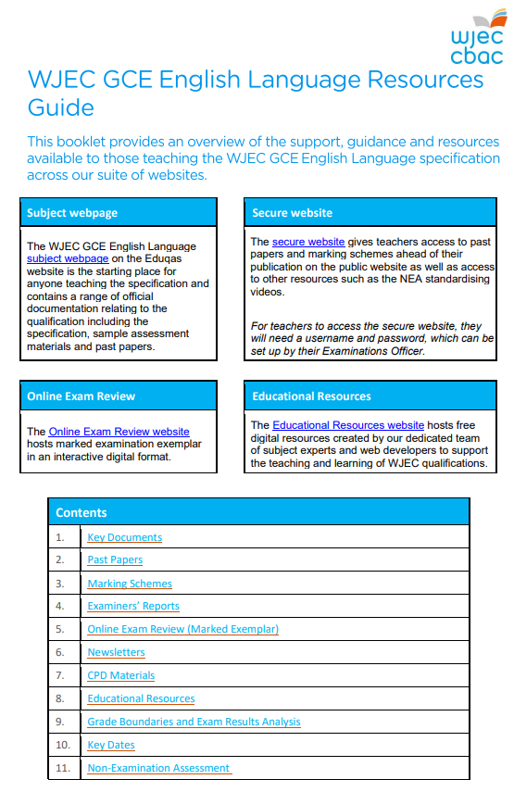

Being mindful of the challenges that teachers and students will undoubtedly face in the coming terms, we have spent time this summer developing teaching and learning resources, guidance materials and student-focused activities to help you through this period.

For each of our GCE English qualifications, our support teams have created Resource Guides for each of our subject areas:

**[GCE English Language](https://www.wjec.co.uk/media/jp2njogl/wjec-gce-english-language-resource-guide.pdf)**

[**GCE English Literature**](https://www.wjec.co.uk/media/ybgh3nc1/wjec-gce-english-literature-resource-guide.pdf)

[**GCE English Language and Literature**](https://www.wjec.co.uk/media/rh1jaa3l/wjec-gce-english-language-and-literature-resource-guide.pdf)

These are essential dynamic documents for teachers as they curate the key support, guidance and resources offered by Eduqas.

We have also added to the wide range of free digital resources available on the [**Digital Resources website**](https://resources.wjec.co.uk/) to support the delivery of our English qualifications.

**GCE English Language**:

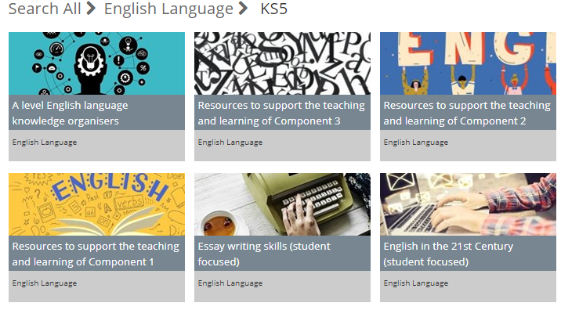

[**Knowledge Organisers**:](https://resources.wjec.co.uk/Pages/ResourceSingle.aspx?rIid=3255) written by Sara Thorne, a collection of sample knowledge organisers to support the learning of A level Language covering open word classes, phrases and spoken language.

These could be used for revision or as a starting point for creating your own knowledge organisers.

On the [**GCE English Language**](https://www.wjec.co.uk/qualifications/english-language-as-a-level/?sub_nav_level=course-materials#tab_resources) page, you will find a series on student booklets for teachers to use as part of any blended or flipped learning approaches.

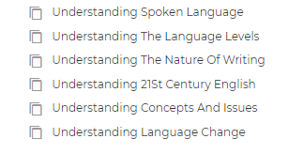

These editable materials collate many of the activities we have produced over the years in thematic booklets. These aim to support students develop their understanding of six different aspects of language study either working independently or as part of a curated programme put together by teachers to try to cover some learning remotely.

These can be found by following *Resources>Key Documents>Resources for Teachers*.

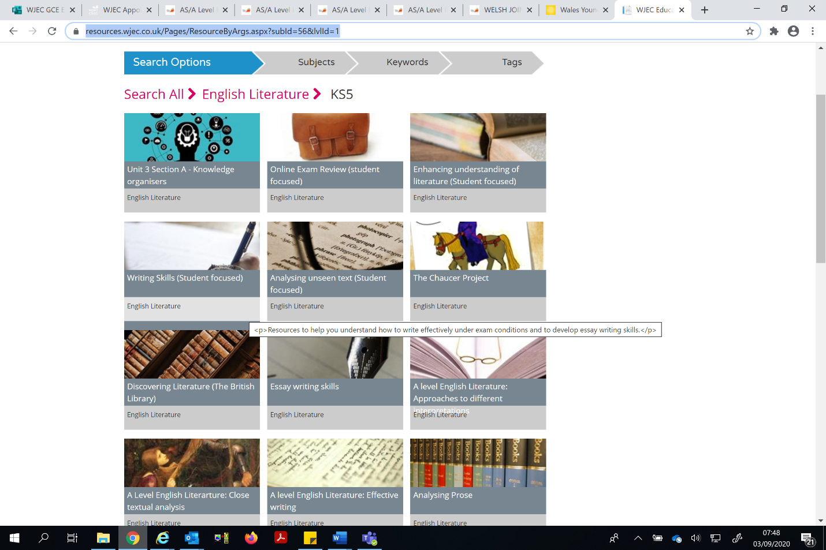**GCE English Literature**:

[**Knowledge Organisers**](https://resources.wjec.co.uk/Pages/ResourceByArgs.aspx?subId=56&lvlId=1): written by Principal Examiners, a collection of sample knowledge organisers to support the learning of A level Literature covering essential elements for different units. Unit 3 Section A is currently available, and more knowledge organisers will be added soon.

These could be used for revision or as a starting point for creating your own knowledge organisers.

There is also available a series of interactive student resources to support preparation for [enhancing the understanding of literature](https://resources.wjec.co.uk/Pages/ResourceSingle.aspx?rIid=3056), [developing writing skills](https://resources.wjec.co.uk/Pages/ResourceSingle.aspx?rIid=3055) and [analysing unseen texts](https://resources.wjec.co.uk/Pages/ResourceSingle.aspx?rIid=3054).

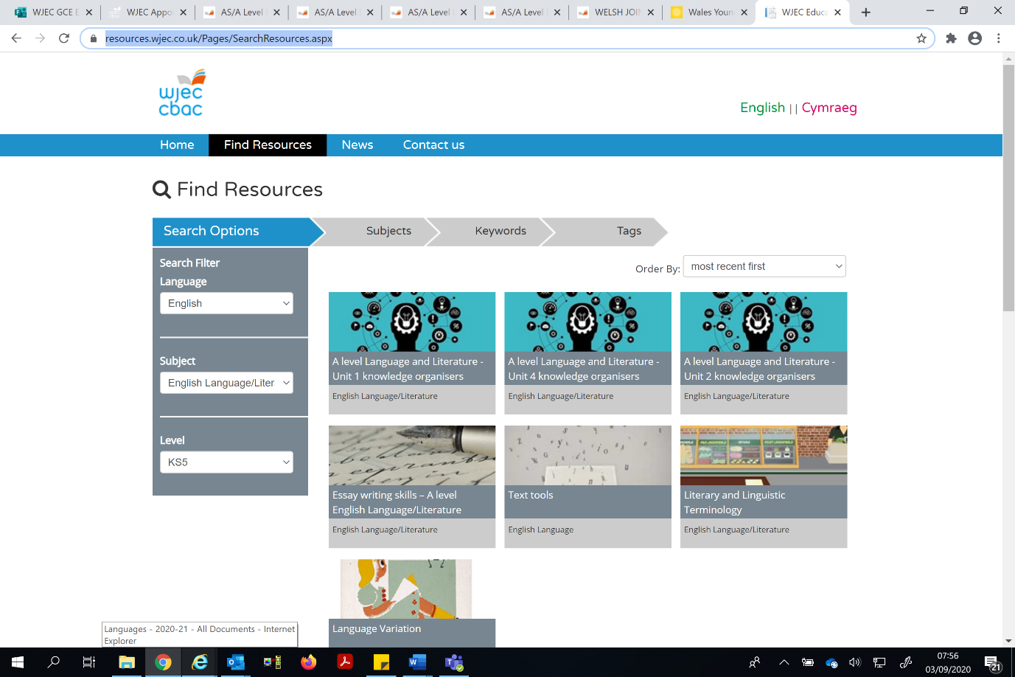**GCE English Language and Literature**:

[**Knowledge Organisers**](https://resources.wjec.co.uk/Pages/ResourceByArgs.aspx?subId=57&lvlId=1): written by Principal Examiners, a collection of sample knowledge organisers to support the learning of A level English Language and Literature covering essential elements for different units.

These could be used for revision or as a starting point for creating your own knowledge organisers.

In addition to those resources on the dedicated website, centres will find very useful material on the [**WJEC secure website**](https://www.wjecservices.co.uk/login.asp), such as:

* previous A level CPD material: including lots of practical, classroom-focused activities;
* NEA Standardising Material: videos and commentaries to help internal standardisation of NEA work;
* past papers and mark schemes.

Coming soon to the Digital Resources site!

We have been working closely with our Principal Examiners to create a series of **exam walk-throughs** aimed at students. These resources offer practical hints and tips on how to effectively approach questions in the examination paper. Using questions from 2019 exam papers, the PowerPoint with audio and script in the notes will walk you through a mock examination paper, helping students revise and practise useful exam techniques. Students can complete the “mock” in a single sitting, tackle one or two questions at a time or revisit some parts of the presentation to reinforce their learning.

Additionally, **free, pre-recorded materials** will also available in the form of voiced-over PowerPoints. For English Language these will cover an Introduction to Early Modern English; Sara Thorne Amplifying the Assessment Objectives; and further NEA guidance. For English Literature, we will be sharing guidance on assessment, giving you some insight into the training which we give our examiners during an examination series. For English Language and Literature, there will be a general introduction to the specification.

We will inform centres as soon as these are uploaded to the website.

4. Professional Learning 2020/21

During the 2020/21 academic year, our Professional Learning events will all move online. Live twilight webinars will be expert-led, two-hour, interactive workshops, designed for you to get all the latest information on qualifications and assessments, an insight into teaching resources available, and a range of practical tips and strategies for the classroom. We hope that there will be something in this offering that interests you and will remind you that we have a wider programme of professional learning for our GCSE English qualifications, for which details and bookings are on the WJEC website.

**A level English Language Live Webinars**:

10 November: [**Assessing analysis and evaluation skills – moving from ‘sound’ to ‘perceptive’**](https://eduqas.ticketsolve.com/shows/873620656/events/129307624?locale=en-GB)will focus on:

* exploring different questions where analysis and evaluation are being tested across different units;
* giving opportunities to assess like an examiner, specifically what characterises ‘sound’ responses and compared with ‘perceptive’ analytical/evaluative responses;
* and teaching and learning strategies for moving students from ‘sound’ to ‘perceptive’.

17 November: [**Using comparative judgement approaches for consistent assessment**](https://eduqas.ticketsolve.com/shows/873620657/events/129307626?locale=en-GB)will focus on:

* establishing the general characteristics shared in responses at different levels;
* looking at how to differentiate between the bands with an exploration of the assessment criteria;
* and a discussion of strategies and suggestions for moving students from Band 3 to Band 5.

25 November: [**What good creative writing looks like - understanding AO5 banded qualifiers**](https://eduqas.ticketsolve.com/shows/873620658/events/129307628?locale=en-GB)will focus on:

* what examiners can credit in creative responses;
* comparing different approaches students could take to the same task;
* discussing strategies and suggestions for moving students’ creative writing from Band 3 to Band 5.

**A level English Literature Live Webinars**:

15 October: [**Preparing for the summer 2021 exam series**](https://wjec.ticketsolve.com/shows/873620628/events/129307576?locale=en-GB)will focus on:

* key lessons learnt from the 2019 exam series
* practical tips on how to prepare for summer 2021
* clear focus on key messages for each component.

4 November: [**Teaching and assessing drama**](https://wjec.ticketsolve.com/shows/873620626/events/129307574?locale=en-GB) will focus on:

* strategies for teaching drama in the classroom
* organising responses to extracts from Shakespeare
* approaches to comparing plays
* guidance on assessment.

10 February [**Teaching and assessing poetry**](https://wjec.ticketsolve.com/shows/873620627/events/129307575?locale=en-GB) will focus on:

* strategies for teaching poetry in the classroom
* approaches to comparing poems
* developing confidence with poetry
* guidance on assessment.

**A level English Language and Literature Live Webinars**:

10 November [**Preparing for the summer 2021 exam series**](https://wjec.ticketsolve.com/shows/873620624/events/129307569?locale=en-GB) will focus on:

* key lessons learnt from the 2019 exam series
* practical tips on how to prepare for summer 2021
* clear focus on key messages for each component.

24 November [**Making connections between texts (AO4)**](https://wjec.ticketsolve.com/shows/873620623/events/129307568?locale=en-GB) will focus on:

* teaching approaches
* discussion of exemplar material
* key tips for making the most of AO4
* guidance for assessment.

15 December [**Responding to an extract from Shakespeare**](https://wjec.ticketsolve.com/shows/873620625/events/129307573?locale=en-GB) will focus on:

* improving candidates’ performance in responding to extract from the work of Shakespeare
* approaches to teaching with a clear focus on dramatic techniques
* discussion of exemplar material
* guidance for assessment.

5. A level English Literature NEA

For A level English Literature, please remember that text choices need to be approved by WJEC. The deadline for submitting your centre’s texts is the end of November. You can find the form for submitting both pre-2000 and post-2000 texts on the [**secure website**](http://www.wjecservices.co.uk/). If texts have been approved in previous years, there is no need to submit these titles again.

6. Poetry Competition

The next generation of poets is waiting to be found. One of them could be a student at your centre. Poetry Wales is running a UK-wide poetry competition for young people aged between 10-17 on the theme of empathy. You can find more details here: <https://poetrywales.co.uk/youngpoets/>

7. Key dates

Key dates for the coming year have been posted on the WJEC website:

* [AS/A level English Language](https://www.wjec.co.uk/media/hvul0zhd/wjec-gce-english-language-important-dates-2020-21.pdf)
* [AS/A level English Literature](https://www.wjec.co.uk/media/ozvhtvju/wjec-gce-english-literature-important-dates-2020-21.pdf)
* [AS/A level English Language and Literature](https://www.wjec.co.uk/media/qevkory4/wjec-gce-english-language-and-literature-important-dates-2020-21.pdf)

8. Next newsletter

The next issue will be sent out in January. In the meantime, if you have any questions, please get in touch.

|  |  |
| --- | --- |
| **Kirsten Wilcock**  Subject Officer  AS/A level English Language | **Rhodri Jones**  Subject Officer  AS/A level English Language and Literature  AS/A level English Literature |

|  |  |
| --- | --- |
| **Aston Jones**  Subject Support Officer | **Mike Williams**  Subject Support Officer |

[**gceenglish@wjec.co.uk**](mailto:gceenglish@wjec.co.uk)

029 2240 4292