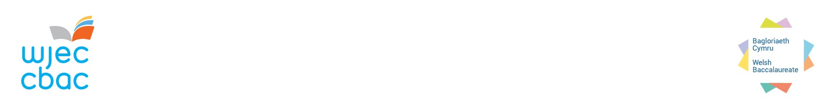To achieve the Welsh Baccalaureate, candidates must achieve the Skills Challenge Certificate together with specified supporting qualifications completed during the lifetime of a candidate’s registration.

**AOI1 FORM - WBQ AGGREGATION**

**TABLE 1:** Please list **all other Awarding Organisations** with whom you intend to sit **Level 1, Level 2, or Level 3 skills or vocational qualifications.** This information will be usedto help us aggregate candidates’ Welsh Baccalaureate.

|  |  |  |  |
| --- | --- | --- | --- |
| Awarding Organisation | Level 1 | Level 2 | Level 3 |
| *e.g. LIBF Level 1 / Level 2 Lessons in Financial Education Certificate (LiFC)* | *x* | *x* |  |
| *UAL Level 3 Extended Diploma in Music Performance & Production* |  |  | *x* |
|  |  |  |  |
|  |  |  |  |
|  |  |  |  |
|  |  |  |  |
|  |  |  |  |
|  |  |  |  |
|  |  |  |  |

|  |  |  |  |  |  |
| --- | --- | --- | --- | --- | --- |
| Name | Candidate number | UCI | DOB | Level | Reason |
| *Sally Hughes* | *54321* | *68140* | *29.08.07* | *Advanced* | *Achieved Maths / English at previous centre - 68452* |
| *Helen Lewis* | *59876* | *68555* | *14.05.07* | *N/F* | *Name change – previously known as Helen Griffiths* |
|  |  |  |  |  |  |
|  |  |  |  |  |  |
|  |  |  |  |  |  |
|  |  |  |  |  |  |
|  |  |  |  |  |  |
|  |  |  |  |  |  |
|  |  |  |  |  |  |
|  |  |  |  |  |  |

**TABLE 2:** Please list where there has been a centre move, a change of name, a qualification achieved abroad, or Literacy/Numeracy achieved before 2012. Information provided will be used by WJEC to conduct manual data searches. WJEC may contact the centre and request further evidence.

The forms can be completed and submitted electronically to [wbq@wjec.co.uk](mailto:wbq@wjec.co.uk). Extra lines should be added to the table as necessary.

Please return by: **30th April 2025**