**GCE ENGLISH LANGUAGE**

**Units 2 and 4: Creative and Critical Use of Language**

**Teaching and Learning Resources**

*Exercise 1: Grammar for creating meaning*

Ernest Hemingway rewrote a newspaper report as a story. It has 11 sentences and 129 words.

They shot the six cabinet ministers at half past six in the morning against the wall of the hospital. There were pools of water in the courtyard. There were wet dead leaves on the paving of the courtyard. It rained hard. All the shutters of the hospital were nailed shut. One of the ministers was sick with typhoid. Two soldiers carried him downstairs and out into the rain. They tried to hold him up against the wall but he sat down in a puddle of water. The other five stood very quietly against the wall. Finally the officer told the soldiers it was no good trying to make him stand up. When they fired the first volley he was sitting down in the water with his head on his knees.

**How is language used to create meaning in this text?**

*Task 1: Underline all the simple sentences in red; the compound sentences in green; and the complex sentences in blue.*

They shot the six cabinet ministers at half past six in the morning against the wall of the hospital. There were pools of water in the courtyard. There were wet dead leaves on the paving of the courtyard. It rained hard. All the shutters of the hospital were nailed shut. One of the ministers was sick with typhoid. Two soldiers carried him downstairs and out into the rain. They tried to hold him up against the wall but he sat down in a puddle of water. The other five stood very quietly against the wall. Finally the officer told the soldiers it was no good trying to make him stand up. When they fired the first volley he was sitting down in the water with his head on his knees.

*Task 2: Circle all the transitive verbs in red and all the intransitive verbs in green.*

They shot the six cabinet ministers at half past six in the morning against the wall of the hospital. There were pools of water in the courtyard. There were wet dead leaves on the paving of the courtyard. It rained hard. All the shutters of the hospital were nailed shut. One of the ministers was sick with typhoid. Two soldiers carried him downstairs and out into the rain. They tried to hold him up against the wall but he sat down in a puddle of water. The other five stood very quietly against the wall. Finally the officer told the soldiers it was no good trying to make him stand up. When they fired the first volley he was sitting down in the water with his head on his knees.

*Task 3: Highlight in yellow all the anaphoric references to the victims (reference back to something mentioned before).*

They shot the six cabinet ministers at half past six in the morning against the wall of the hospital. There were pools of water in the courtyard. There were wet dead leaves on the paving of the courtyard. It rained hard. All the shutters of the hospital were nailed shut. One of the ministers was sick with typhoid. Two soldiers carried him downstairs and out into the rain. They tried to hold him up against the wall but he sat down in a puddle of water. The other five stood very quietly against the wall. Finally the officer told the soldiers it was no good trying to make him stand up. When they fired the first volley he was sitting down in the water with his head on his knees.

*Task 4: Highlight in green all the cataphoric (reference forward to something mentioned later) and pink for all anaphoric references to the perpetrators.*

They shot the six cabinet ministers at half past six in the morning against the wall of the hospital. There were pools of water in the courtyard. There were wet dead leaves on the paving of the courtyard. It rained hard. All the shutters of the hospital were nailed shut. One of the ministers was sick with typhoid. Two soldiers carried him downstairs and out into the rain. They tried to hold him up against the wall but he sat down in a puddle of water. The other five stood very quietly against the wall. Finally the officer told the soldiers it was no good trying to make him stand up. When they fired the first volley he was sitting down in the water with his head on his knees.

*Task 5: Label the adverbials used to indicate when, where and how.*

When, where and how – adverbials

They shot the six cabinet ministers at half past six in the morning against the wall of the hospital. There were pools of water in the courtyard. There were wet dead leaves on the paving of the courtyard. It rained hard. All the shutters of the hospital were nailed shut. One of the ministers was sick with typhoid. Two soldiers carried him downstairs and out into the rain. They tried to hold him up against the wall but he sat down in a puddle of water. The other five stood very quietly against the wall. Finally the officer told the soldiers it was no good trying to make him stand up. When they fired the first volley he was sitting down in the water with his head on his knees.

*Task 6: Identify and list the words and phrases in the semantic field of water.*

They shot the six cabinet ministers at half past six in the morning against the wall of the hospital. There were pools of water in the courtyard. There were wet dead leaves on the paving of the courtyard. It rained hard. All the shutters of the hospital were nailed shut. One of the ministers was sick with typhoid. Two soldiers carried him downstairs and out into the rain. They tried to hold him up against the wall but he sat down in a puddle of water. The other five stood very quietly against the wall. Finally the officer told the soldiers it was no good trying to make him stand up. When they fired the first volley he was sitting down in the water with his head on his knees.

*Task 7: Write a 300 word commentary analysing the effect of these grammatical (and lexical) features.*

Use the following success criteria to assess your work.

My work includes:

* a clear attempt to explain what they have tried to achieve
* an evaluation of the success of the intended effects
* an insightful assessment of effectiveness
* a wide-ranging exploration of the distinctive contextual factors
* a purposeful analysis of chosen language features
* a meaningful analysis of chosen stylistic features
* a thoughtful discussion reflecting on how meaning is shaped
* a consistent and accurate reference to the language levels
* a use of apt and accurate quotation to support points.

*Task 8: Rewrite a news report of an event of your choosing in Hemingway’s style, using grammar to create and possibly change meaning.*

*Exercise 2: Use the suggestions below as 10 minute writing tasks to practise creative writing.*

* Read an opening paragraph from a short story and then continue it.
* Write a news report with the headline, ‘Chocolate is a superfood’.
* Use the senses to describe the scene in a crowded café.
* Write advice for year 7 students on the best food choices for the school website.
* As part of a travel writing series, write an extract from an article entitled, ‘How to pack a rucksack for a weekend away’.
* Script an exchange asking a friend to lend you £50.00.
* Write an extract from a short story entitled, ‘Finding a four-leaf clover’.
* Choose the audience, purpose and form for a piece of writing from the title ‘2 a.m.’.
* Write a review of a TV programme.
* Write a descriptive paragraph painting a portrait of a stranger near you in a queue.
* Buses should be free – argue for or against.
* Write a dramatic monologue – ‘The thoughts of a cathedral gargoyle’.
* A cat or a dog? Discuss.
* Snow.

*Exercise 3:* Imagine you work in the fund-raising department of the Born Free Foundation. You have been asked to write a **persuasive leaflet** to encourage people to support the work of your organisation. The leaflet will be an **insert in a Sunday newspaper**.

|  |  |  |
| --- | --- | --- |
| **CONTEXT:**  Charity fundraising marketing inserted into a national Sunday newspaper on behalf of the Born Free Foundation, which is a charity set up to ensure all wild animals are treated with compassion and respect. | **PURPOSE:**  To encourage readers to support the work of the organisation by donating money to fund its work. | **AUDIENCE:**  Readers of the Sunday newspaper (it is not specified whether the newspaper is broadsheet or tabloid). |
| **FORMAT/STRUCTURE:**   * __________________________________ * __________________________________ * __________________________________ * __________________________________ | **Persuasive Leaflets**  **NOTES:** | **RHETORICAL DEVICES:**   * __________________________________ * __________________________________ * __________________________________ * __________________________________ |
| **TONE (VOCABULARY):**   * _________________________­­­­­­­­­­­­­­­_________ * __________________________________ * __________________________________ * __________________________________ | **TONE (GRAMMAR):**   * ________________________________ * ________________________________ * ________________________________ * ________________________________ | **PRAGMATICS (CULTURAL REFERENCES):**   * __________________________________ * __________________________________ * __________________________________ * __________________________________ |

|  |  |  |
| --- | --- | --- |
| **CONTEXT:**  Charity fundraising marketing inserted into a national Sunday newspaper on behalf of the Born Free Foundation, which is a charity set up to ensure all wild animals are treated with compassion and respect. | **PURPOSE:**  To encourage readers to support the work of the organisation by donating money to fund its work. | **AUDIENCE:**  Readers of the Sunday newspaper (it is not specified whether the newspaper is broadsheet or tabloid). |
| **FORMAT/STRUCTURE:**   * an engaging and/or hard-hitting title * use of bullet points * subheadings to break up the text * captioned images illustrating the charity’s work | **Persuasive Leaflets**  **NOTES:** | **RHETORICAL DEVICES:**   * hypophora * rhetorical questions * hyperbole * emotive tone * direct address * facts and statistics |
| **TONE (VOCABULARY):**   * emotive lexis * adjectives/nouns/verbs/ adverbs which foreground cruelty * adjectives/nouns/verbs/ adverbs which convey a horrified response * adjectives/nouns/verbs/adverbs which convey the goodness of the charity’s mission and accomplishments | **TONE (GRAMMAR):**   * syndetic lists * asyndetic lists * repetition * minor sentences for effect * parallel patterns of devices | **PRAGMATICS (CULTURAL REFERENCES):**   * clearly formulated and expressed authorial persona and viewpoint * original viewpoint (e.g. written from the point of view of a vulnerable animal) * references to famous people who also champion the charity (e.g. Amanda Holden) |

*Exercise 3* – Teacher Notes (students may wish to use the Text B transcript from the 2018 WJEC GCE English Language [Unit 4](http://pastpapers.download.wjec.co.uk/s18-2708-01.pdf) past paper as stimulus)

*Exercise 4:* Reverse Engineering Writing

* Plan a response using the placemat from Exercise 3.
* Write the first draft of the response.
* Produce a 300 word linguistic commentary of the response you have written. (Writing a commentary on our own work can be very useful in enabling writers to ‘see’ their own writing the way their readers would encounter it.)
* Re-draft the original writing in the light of this analysis.
* Highlight those features you have amended or added and be prepared to discuss reasons.

*Metacognitive Planning Strategy: PAFT Questioning*

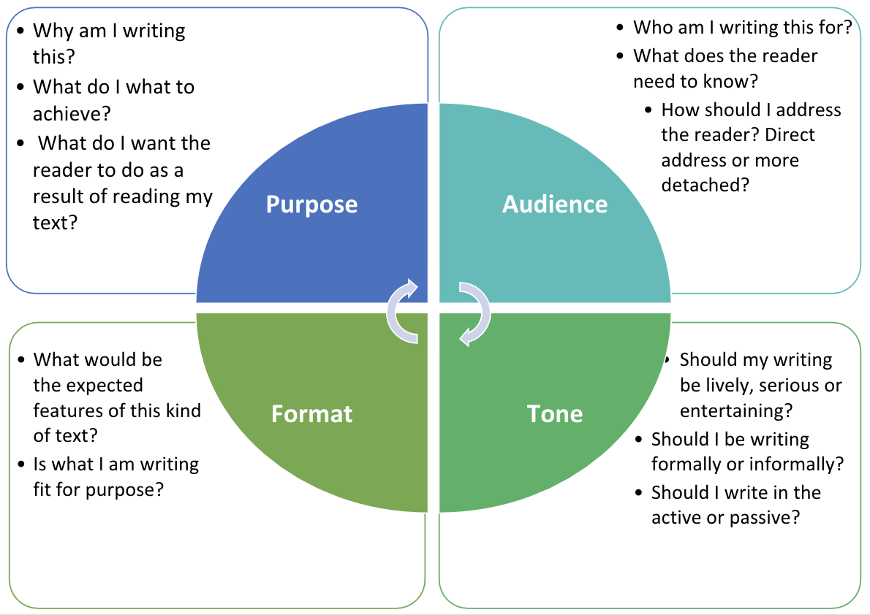

|  |
| --- |
| **Age:** |
| **Family circumstances:** |
| **Educational background:** |
| **Occupational background:** |
| **Likes:** |
| **Dislikes:** |
| **Proudest moment:** |
| **Biggest regret:** |
| **Dreams and ambitions:** |

*Exercise 5*: Character Profile – Use the table below to jot down your notes to help you create a character profile for writing a dramatical monologue based on a stimulus text.