**LEVEL 3 FOOD SCIENCE AND NUTRITION**

**Frequently asked questions**

What units do I need to complete to achieve a Certificate?

Unit 1 External and Internal.

What units do I need to complete to achieve a Diploma?

Unit 1 External and Internal, Unit 2 and Unit 3 or Unit 4.

Where can I find exam dates?

There is a link on the subject page to direct you to the Key dates and Timetable document. These can also be found on the open WJEC/Eduqas website under Administration > Key dates and Timetable.

What is the percentage for each unit?

Certificate – Unit 1 External – 50% Unit 1 Internal – 50%

Diploma – Unit 1 External -25% Unit 1 Internal – 25% Unit 2 – 25% Unit 3 or Unit 4 – 25%

Can they re-sit a unit?

Unit 1 and Unit 2 External examination can be re-sat twice. Unit 1 (Internal), Unit 3 or Unit 4 can o be re-sat once.

I cannot gain access to the secure website, can you help?

Your examination officer will have this information we are unable to provide this for you.

Where can I find past paper and marking schemes?

These can be found on the subject pages or the secure website under Resources > Past paper and marking schemes.

I missed CPD training do you have any more taking place?

CPD take place in the autumn term, dates are released around the beginning of June and can be found under Professional Learning Courses on the WJEC/Eduqas open website.

We have previous CPD material available to download from our Secure Website under Resources > Subject Specific Material including CPD and exemplar.

We also have a range of resources available on Food science and Nutrition subject page.

**Unit 1**

Why is there an overlap between what is assessed in the Internal assessment and what is assessed in the External for Unit 1?

Unit 1 is a synoptic unit therefore learners must be assessed on all the Assessment Criteria each series.

The examination will assess all the Learning Outcomes each series (apart from LO5 and LO6 as these are specific to the practical assessment) but not all the ACs therefore there must be coverage of all the ACs in the evidence presented for the internal assessment.

**External Assessment**

How long is Unit 1 external exam paper?

1hour 45 mins which includes 15 minutes of reading time.

In some websites and some books there seems to be varying numbers referred to as the total no of amino acids (20 or 22), the essential amino acids for adults (9 or 10) and essential amino acids for children (8 or 9) which is correct?

As a guide the following information is correct.

Essential amino acids - Isoleucine, Leucine, Lysine, Methionine, Phenylalanine, threonine, Tryptophan, Valine.

Children - Arginine, Histidine.

Non-essential amino acids - Alanine, Asparagine, Aspartic acid, Cysteine, Glutamic acid, Glutamine, Glycine, Proline, Serine, Tyrosine

**Internal Assessment**

Where do I find the assessment briefs?

Assessment briefs can be found on the secure website under Resources > Non-Examination Assessment Task > Use drop down boxes (see image below)

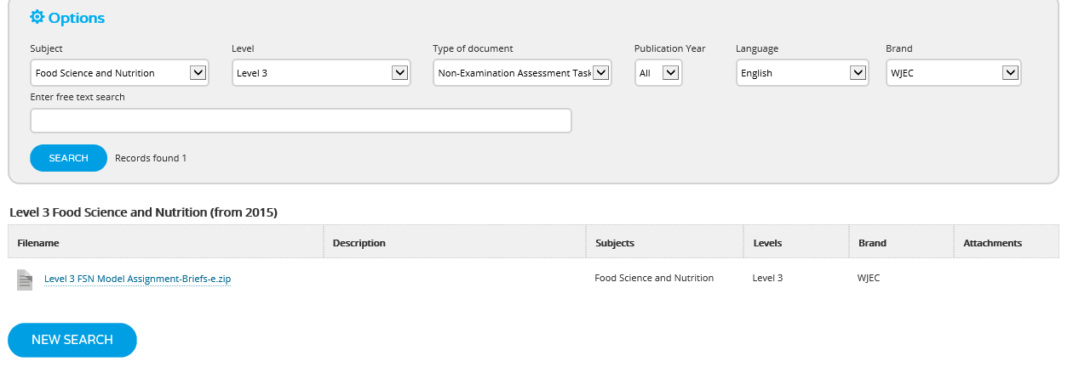

How many Assessment Briefs are there for Unit 1?

3 Assessment briefs are available, these can be found on the secure website, there is also a Sample one on the open website – that could be used as a “mock” assessment.

Do learners have to choose a specific target group?

Yes, this is recommended.

In Options A, B and C the briefs have been written in a way that allows learners the opportunity to choose a target group.

This will allow learners to focus on planning dishes to meet the needs of one specific group e.g. young adults for the spa brief.

They need to select/ focus on a group in order to explain how the chosen dishes meet the nutritional needs of their chosen specific group. This will then address:

AC 2.2, AC3.1, AC 3.2, AC 3.3, AC 3.4, AC 4.1 and AC 4.2.

This evidence could be presented in Task 1 via a written introduction to the task e.g. "Reasons for choice" prior to planning or could be presented as preparatory notes they could refer to in the interview for Task 3. This assessment criterion only needs to be covered once in the evidence presented.

Teachers can identify where this has been evidenced in the assessor’s comments section on the mark record sheet. Hence there is no issue if a different approach is adopted by learners.

Can we have clarification of what nutrients to teach for LO2, AC2.1

We recommend the main macronutrients and micronutrients are taught in addition to Dietary Fibre (NSP) and water.

Direct questions in the Unit 1 examination will only be asked on the main ones:

Fat soluble Vitamins – A retinol and carotene, D, E and K

Water soluble B1, 2, 3, 6, 12 AND B9 folic acid, C

Minerals – Calcium, iodine, iron, phosphorus, potassium, sodium and zinc

However, if learners were to discuss additional ones in their responses (i.e. if the question was broad as oppose to specific) credit would be given.

Unit 1 internal assessment: Have learners got to have an interview?

It is advantageous for learners to have an interview as it can help prepare them for "real life" interviews. The interview can be interpreted as hypothetical, but some learners may benefit from a verbal discussion in relation to the AC s. This can then be evidenced via a witness statement.

Also producing preparatory notes that suit their learning style in readiness for an interview is good experience, it allows them to present information possibly in more innovative ways and can also help prepare them for the written examination.

Are there set questions that need to be asked for the interview?

Standard questions have not been produced as the decision was made to allow teachers the flexibility of wording questions to suit the needs of the cohort.

The AC s shown on page 4 can be used as a basis for questions to ask your students.

Any notes the learner prepares should cover any of the AC s that may not already have been evidenced within their justification of dishes and order of work.

It is anticipated these will be:

AC 1.4 (there may be reference to this in the order of work, but this is dependent on their choice of dishes)

AC 2.1

AC 2.3

If it is more straightforward all the ACs identified for Task 3 (p.4) may be evidenced in this way

Some centres previously have asked questions based on any of the ACs that they do not find evidenced in learners' written work, as learners should cover all ACs to gain a grade.

Do you have a link for calculating BMR?

The following link is recommended:

A calculation that works out the BMR for an individual is available on an online  
calculator. See: [www.calculator.net/bmr-calculator.html](http://www.calculator.net/bmr-calculator.html)

Do learners need to analyse any data collected when selecting the dishes for the practical assessment?

Yes, it is expected that learners will show application of knowledge when using nutritional software packages to justify the choice of dishes.

Is there a practical skills list for Unit 1?

Some suggestions have now been published and can be found on the subject page under Key documents > Teacher Resources.

How many dishes do they need to make?

Each brief for Unit 1 specifies a three-course meal which traditionally would be a starter, main course, dessert and any accompaniments.

This could be 3-6 food items as selected by the learners. The focus is to "showcase skills" hence number of dishes need not be restricted to three.

Producing a three-course meal allows the learners to justify their choice of dishes in relation to how the courses complement each other in addition to how they meet the needs of the target group.

Each option has set standard tasks:

Select suitable dishes to meet the requirements of your allocated specific group and showcase your use of

• three advanced preparation techniques

• three advanced cooking techniques

• complex presentation skills

These tasks cannot be changed but the scenario / brief can be changed, thus if centres wanted to reword the brief to move away from traditional three course e.g. dishes available at a hot buffet this would be acceptable.

Or learners could produce a starter and 2 main courses or one main and 2 dessert as long as the dishes meet the needs of the target group, choices were fully justified, and the required skills were demonstrated.

How many covers do the learners have to cook for?

It does not state the number of covers but two is the benchmark we would recommend.

However, if there are legitimate reasons why the learner can only prepare one cover (cook for one person) they will not be penalised. There is no issue for a learner making larger portions if that fits in with their personal requirements.

Is the 3 ½ hour practical session mandatory as timetabling could be difficult?

Yes, it states on page 3 of the Model assignment that the time allowance for the practical session is 3 ½ hours. If centres do not accommodate this control they will be doing their learners a dis-service, as having less time will diminish the skills that can be displayed. Having a mandatory 3-hour session for the new GCSE should support the request for this to continue post KS4.

Are photographs required?

Photographic evidence is required to showcase the dishes learners have produced. In order to reduce colour printing costs, this work can be submitted electronically if that suits the centre

How much detail do we need to write on the Mark record sheet?

It is acceptable for assessors to highlight or tick the boxes to indicate the points you are awarding for each AC; however, any exemplification you can provide particularly if the evidence is not clearly visible is greatly appreciated to support the moderation process.

The mark scheme refers to "the case study" is this the same thing as the learner brief?

Yes, each option is based on a scenario which may be referred to as a scenario, case study or Learner Assignment Brief.

If students retake UNIT 1 paper again in year 13, which mark is awarded? i.e. if gained a Merit in year 12 and gain a Pass in year 13 retake, does the Merit go forward?

Yes, as for all resit examinations the highest mark is carried forward as long as the end % terminal rule is applied.

**Unit 2**

**External assessment**

Having this assessment in May with three weeks to complete will be difficult with revision programmes for each subject and so close to the A level exams, is this timing reviewable?

As this is an externally assessed unit it has to take place during the summer examinations series. It will be released on May 1st and centres will need to ensure the learners have 8 hours under controlled conditions to complete the assessment prior to the evidence being sent to WJEC for marking. It is in effect the second examination.

Do they have to do the assessment in the exam room with other external exam students or can we room them in an IT room for 8 hrs?

The room can be an IT room, it does not require an exams room. The 8 hours does need to be implemented under exam conditions but can be timetabled in normal lesson times with the teacher supervising.

Are they allowed to take in photocopied annotated sheets from textbooks?

If the photocopied sheets are part of their class notes in their folders this is allowed. No textbooks are allowed in the room.

**UNIT 3**

Task options: Could WJEC include the method for making the bread for the festive buns and the quiche?

Standard recipes can be made available or centres may select their own.

Is practical experimental work time included in the 12 hours? Or can it be outside the 12 hours?

Technically yes as it is part of Task 3, however centres need to be realistic if for example if learners need to leave ice – cream overnight to freeze, this time would not be counted.

It is the explanation of the findings that is the focus of this unit as oppose to the skills they show (which is unit 1).

**Tasks**

**1.** Identify the issues that need to be addressed.

**2.** Investigate food production problems associated with comments on The Nothing New Dairy blog and review internal laboratory reports.

**3.** Carry out experimental work to investigate the problems.

**4.** Process the data from your experiments and justify your findings.

**5.** Present practical options to the management in written format.

**UNIT 4**

Is practical work time included in the 14 hours? Or can it be outside the 14 hours?

As the learners will only produce food items in order to gain information on which to base judgements, or to prove a point, the cooking can take place outside the set hours. There is no credit for producing dishes in this Unit.

**Tasks**

**1.** Plan research into current issues affecting food science and nutrition.

**2.** Investigate an issue in food science and nutrition.

How do we work out the final Diploma grade?

The marks/points from each unit are converted to UMS marks and the grade will be awarded as shown on page 12 of the Specification

|  |  |  |  |  |  |  |
| --- | --- | --- | --- | --- | --- | --- |
| **Unit**  **Number** | **Unit Title** | **Assessment** | **Total**  **UMS**  **mark** | **UMS grade boundaries** | | |
| **D** | **M** | **P** |
| 1 | Meeting Nutritional Needs of Specific Groups | Internal | 100 | 80 | 60 | 40 |
| External | 100 | 80 | 60 | 40 |
| 2 | Ensuring Food is Safe to Eat | External | 100 | 80 | 60 | 40 |
| 3 | Experimenting to Solve Food Production Problems | Internal | 100 | 80 | 60 | 40 |
| 4 | Current Issues in Food Science and Nutrition | Internal | 100 | 80 | 60 | 40 |

Does the Food teacher have to be the invigilator, or can it be any other teacher/invigilator?

The Food teacher can invigilate, or it can be another member of staff.

Will universities recognise this course?

The qualification attracts UCAS and performance points, thus it will count within learners’ portfolio when applying for Higher Education places.

Distinction* - 56 points

Distinction – 48 points

Merit – 32 points

Pass – 16 points

The Certificate in Food Science and Nutrition will receive half of these points.

Where can I find Grade Boundaries for each unit?

Grade boundaries can be found on the subject page under Have you seen……… Grade boundaries.

What paperwork should be filled in for each controlled assessment?

For Unit 1 and Unit 3 Mark Record Sheet, Time sheet and Observation Record Sheet. Unit 4 Mark Record Sheet and Timesheet. All can be found on the subject page.

Do we need to fill in forms for Unit 2?

An examination pack will be sent to your exams officer but you will need to complete a Timesheet which can be found on the subject page under Resources > Controlled Assessment Forms.

Do you have textbooks/revision guides?

We do not sell any textbooks/revision guides at WJEC, but these can be purchased through Illuminate Publishing or Hodder Education.

Do you have any exemplar material?

Yes, this can be found on the secure website under Resources > Subject Specific materials including CPD and Exemplar (see image below)

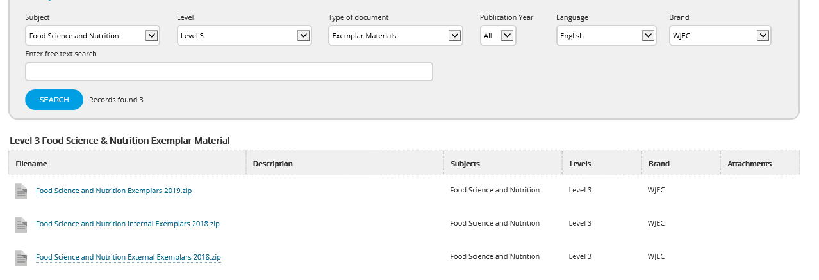

How long do they have to complete each controlled assessment?

Unit 1 – 9 ½ hours.

Unit 3 – 12 hours

Unit 4 – 14 hours

Details can be found in the Sample Assessment Material on the subject page.

Is there a page limit to the written evidence for each internal units?

The control for this work is time specific not page specific. As a rough guide, learners should produce approx. 400 words per hour.

Can students take in personal notes? If so – what form should this take?

All class notes (paper or electronic) from the learning experience can be taken into the controlled assessment sessions. After the first session these should be securely monitored to ensure they’re not added to outside of controlled conditions. For example, they should be taken in after every session and kept secure in the classroom or held on a secure server (this also applies to the live work).