**Suggested activities:**

1. In responding to texts, learners could apply the colour-coded language levels below to investigate the effects of linguistic choices made by the writers. The grid is differentiated to reflect the relative levels of difficulty of the components listed in the framework.
2. When looking at candidate exemplar, get learners to assess the quality of these responses using the language levels grid below.
3. Learners could use highlighters to identify relevant and irrelevant aspects of responses and then improve these exemplars in the light of this peer assessment.
4. Using the mark schemes provided by WJEC and the commentaries provided by the Principal Examiner, students could self/peer assess their own improved responses.
5. Produce colour-coded grids of terminology as appropriate to their point of study in the course then challenge learners to include a rainbow of terminology in their analyses. These could become increasingly more detailed to reflect growing knowledge and understanding.

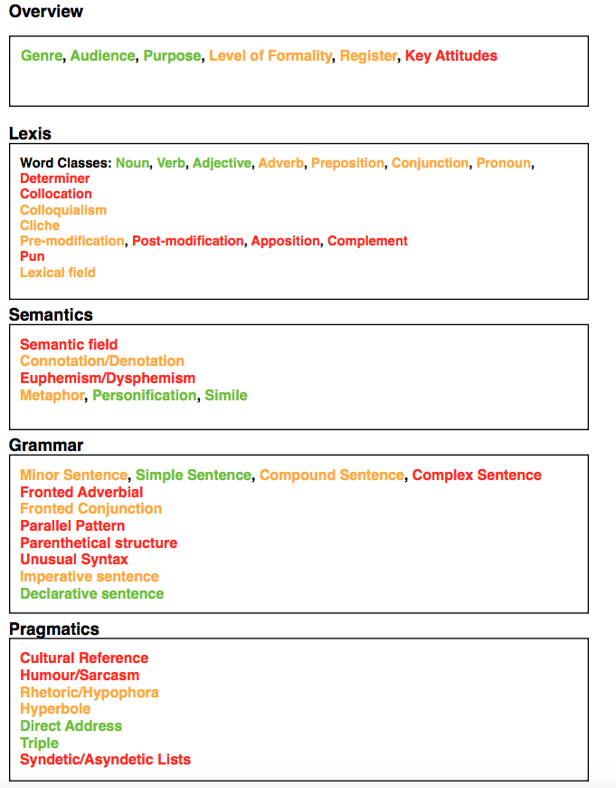

**Key**

**Basic**

**Increasingly   
competent**

**Apt and precise**